FDA Bans Artificial Trans Fats by 2018
Strengthen Your Core with Plank Exercises
Core muscles are one of the most active muscle groups in the body. Whether you are typing, putting on your shoes, vacuuming or playing basketball, you are engaging your core muscles in some capacity. Because you use core muscles for so many activities, it is important to keep them strong and flexible. There are several specific benefits to maintaining a healthy core:
- Strong back muscles. Many people suffer from debilitating low-back pain. A strong core can relieve the lower back from extra strain and pressure.
- Improved balance and stability. A strong core stabilizes your whole body, increasing your range of motion and decreasing your risk of falling.
- Good posture. Often overlooked, posture is an important factor in overall health. By standing tall, your core muscles can minimize wear on the spine and allow you to breathe more deeply.
Core fitness should be factored into any exercise plan. The plank pose is a popular and effective exercise that is great no matter what your fitness goals are.
To try the plank, get into a pushup position. Bend your elbows so your forearms are resting on the floor directly underneath your shoulders. Focus on creating a straight line with your body from head to toe, and try to hold the pose for as long as you can (if this is too challenging at first, you can try bending your knees). Many people struggle to hold a plank pose for 30 seconds on their first attempt, but, with regular practice, you should be able to hold the position for longer intervals. A good goal if you’re just getting started is to work up to a two-minute plank.
Once you are able to hold this position for two minutes, you can move on to more advanced versions of the plank pose, such as lifting an arm or leg, or resting your forearms on an exercise ball.
Presented by: Your Employer and Sullivan Benefits

The Food and Drug Administration (FDA) has announced that artificial trans fats are no longer Generally Recognized as Safe (GRAS) and is requiring that they be phased out of the food supply by 2018.
While trans fat does occur naturally in some meat and dairy products, many processed foods, such as crackers, coffee creamer and margarine, contain artificial trans fats. Artificial trans fats are created in partially hydrogenated oils (PHO)s, which are oils that have been infused with hydrogen. This process keeps the oils solid at room temperature, and is used to maintain flavor and increase the shelf life of processed foods. Intake of trans fat has been shown to cause various health problems, including high cholesterol and coronary heart disease.

INSERT YOUR
LOGO HERE
Get the Nutrition Facts
As you and your family strive to eat healthier, you should be aware of what is in the food you consume. The best way to know what is in the food products you buy is to read the nutrition facts on food labels.
The following information on labels will help you understand how much is in a portion and how this compares to recommended intake:
- Serving size – The serving size lists the recommended amount to be eaten by a single person. The rest of the nutrition facts are based on this amount.
- Calories and calories from fat – Especially important if you’re trying to lose or maintain weight, these numbers tell you how many calories are in each serving and where they’re coming from.
- Percent daily values – Based on the recommended consumption of 2,000 calories a day, this value indicates how the food product compares to recommended amounts.
When reading ingredients on a product label, keep in mind that ingredients are listed in descending order: ingredients with the greatest amount will be listed first, followed by ingredients used in lesser amounts.

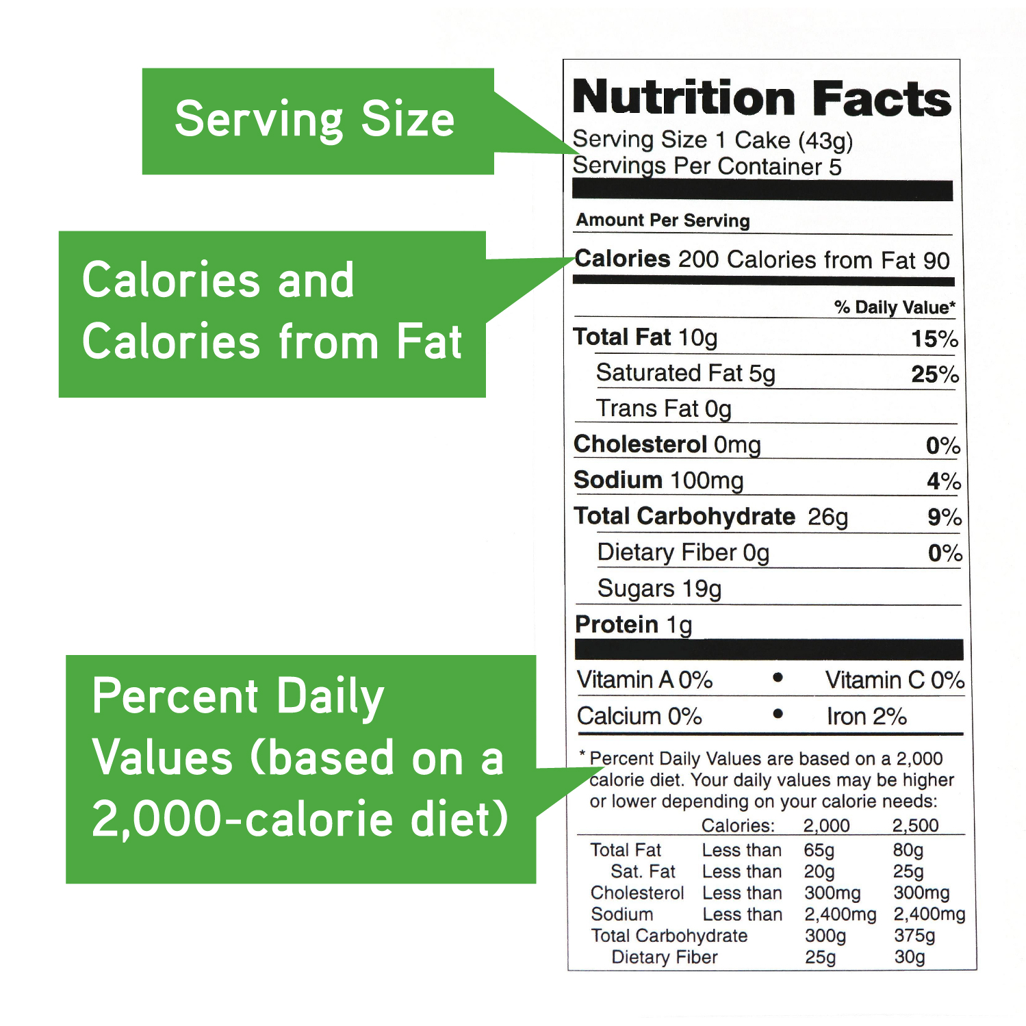
Food Label Breakdown

Fruit Salad with Yogurt
This summery salad incorporates fresh fruit, yogurt and almonds for a satisfying and healthy dessert.
- 2 cups strawberries, sliced
- 1 cup blueberries
- 1 cup pineapple chunks
- 3 Tbsp. 100 percent pineapple or other fruit juice
- 2 cups plain, low-fat yogurt
- 2 Tbsp. almonds, sliced or slivered

Wash the fruit.

Combine fruit and pineapple juice in a large bowl and let stand for 15 minutes.

Spoon 1 cup fruit salad into a small bowl and top with ½ cup yogurt.

Sprinkle almonds on top and serve.

Yield: 4 servings. Each serving provides 171 calories, 4 g of fat, 2 g of saturated fat, 88 mg of sodium, 8 g of protein and 4 g of fiber.
Source: USDA

