Outdoor Exercise Safety Tips
Brought to you by Your Employer and Sullivan Benefits
As we move into summer, many will want to exercise outdoors to stay active and get some fresh air. That’s great news, as experts recommend at least 150 minutes of moderate aerobic activity each week. Working out in hot and humid weather can put extra stress on your body; however, there are simple precautions you can take to protect yourself.
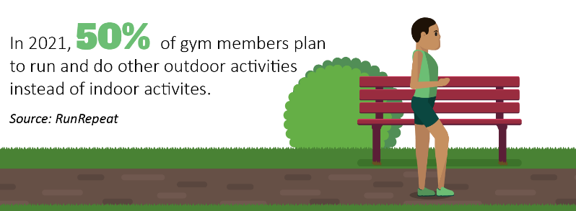

Workout Tips
By moving your workout outdoors, you can boost your mood and improve your concentration. Also, you don’t need to stick to your own yard or neighborhood. Jogging trails, exercise parks, sports fields and stairs provide endless opportunities to switch up your workout. Keep in mind the following tips to safely exercise outside during the summer:
- Avoid the hottest part of the day. If possible, plan your workout before 10 a.m. or after 3 p.m. to dodge those strong sun rays.
- Wear light-colored clothing. Dark colors absorb the heat, while light colors will reflect the sun. Lightweight, loose-fitting clothing will help air circulate and keep you cool.
- Apply sunscreen. Opt for a broad-spectrum sunscreen that’s at least 30 SPF. Reapply every two hours, even if the label says it’s sweatproof. Wearing a wide-brimmed hat can also protect your face from sun exposure.
- Stay hydrated with water. Drink water before you head out, and try to take sips every 15 minutes during your workout—whether you’re thirsty or not.
- Replenish your electrolytes. Instead of reaching for a sports drink after a workout, consider replacing electrolytes through real food like chia seeds, kale, coconut, or fruits and vegetables.
- Listen to your body. If you’re feeling dizzy, faint or nauseous, stop immediately. Sit down in the shade and drink some water until you’re feeling better.
Your body may need to adapt to outdoor workouts, so follow its lead and gradually pick up the pace or intensity. As always, talk to your doctor before you start a new exercise regimen.

Health Benefits of Gardening
It’s likely that you may already have a garden. According to the Garden Media Group, 16 million people started gardening during the pandemic.
Makes: 4 servings
Vinaigrette Ingredients
1 ½ Tbsp. extra virgin olive oil
2 Tbsp. white balsamic vinegar
1 Tbsp. lime juice
1 tsp. sugar
¼ tsp. salt
⅛ tsp. black pepper

Salad Ingredients
1 cup fresh blueberries
1 medium cucumber (chopped)
4 cups fresh arugula
¼ medium red onion (thinly sliced)
¼ cup reduced-fat feta cheese (crumbled)
2 Tbsp. walnuts (coarsely chopped)
4 slices whole-grain bread

Preparations
- Whisk together vinaigrette ingredients in a small bowl.
- Mix together all salad ingredients, except bread, in a large bowl.
- Add the vinaigrette to the salad—and toss to serve.
- Toast bread, then cut each slice into four pieces.

Nutritional Information
(per serving)
Total calories | 212
Total fat | 10 g
Protein | 7 g
Sodium | 368 mg
Carbohydrate | 24 g
Dietary fiber | 4 g
Saturated fat | 3 g
Total sugars | 10 g

Source: MyPlate
As we enter the growing season, gardening is a great way to spend time outdoors—and get some exercise. The Centers for Disease Control and Prevention counts activities like raking and cutting grass as light to moderate exercise—while shoveling, digging and chopping wood are vigorous exercise.
In addition to physical activity, consider these health benefits of gardening:
- Increased vitamin D levels essential for body functions
- Boosted self-esteem
- Improved mood
- Reduced stress and anxiety
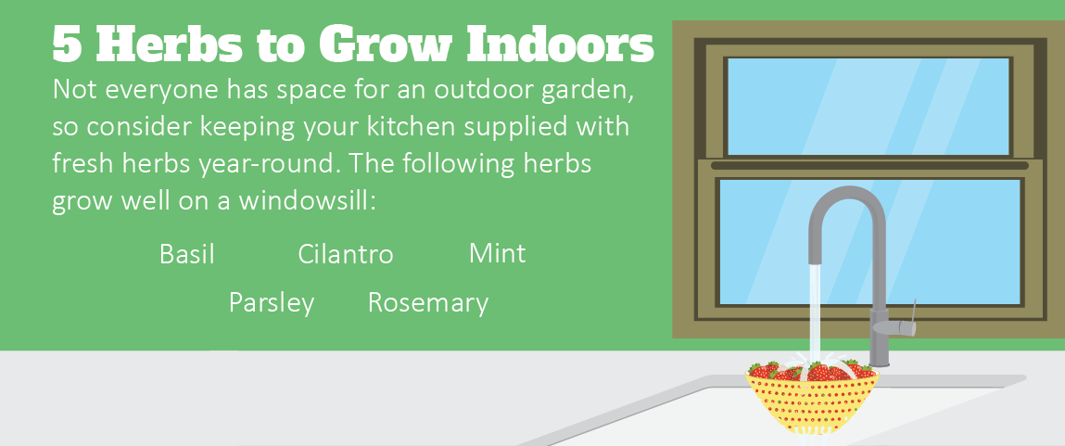
Talk to your doctor to learn more about ways to manage your well-being.

3 Ways to Snack Smartly
It’s completely normal to snack throughout the workday. However, it can especially be tempting to opt for the fast, easy (but unhealthy) option if you are working from home. Keep the following three tips in mind to help you snack smartly during the workday at the office or at home.
- Plan your snacking. Think ahead so you don’t desperately reach for unhealthy items. At the beginning of the week, make or pre-portion your healthy snacks so they’re ready to go.
- Be mindful of portions. Avoid eating directly out of the bag or original container, and portion your snacks before eating.
- Choose healthy snacks. Nibble on fruits, vegetables, whole grains and healthy fats to stay satisfied and full. Pass on the junk food since chips, candy and cookies can leave you feeling sluggish.
You might not have control over where you’re working, but try to work away from the kitchen. Click here to learn about nutritionist-approved snack options.

