Self-care and Your Mental Health
Brought to you by
More than half of adults in the United States will experience mental illness—which refers to a variety of conditions that affect one’s mood, behavior, feelings or thinking—at some point in their life. Mental illnesses can occur occasionally, while others are chronic. Common mental illnesses include anxiety, depression, schizophrenia and bipolar disorder.
Mental Health Awareness Month, observed every May, is a time to raise awareness about mental health, break the stigma and support people with mental illness.
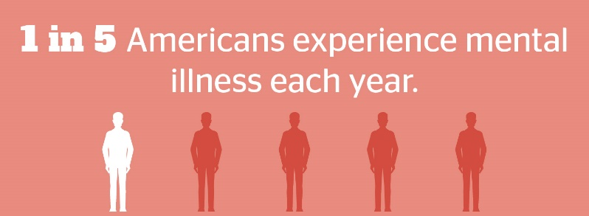

Each condition has its own unique symptoms, but common signs of mental illness include the following:
- Feeling sad, irritable or angry for an extended time
- Feeling excessively paranoid, worried or anxious
- Experiencing extreme mood swings
- Avoiding friends and social activities
- Changing eating habits due to increased hunger or lack of appetite
- Having trouble sleeping or making dramatic sleeping pattern changes
One or two of these symptoms alone can’t predict a mental illness, but they may indicate a need for further evaluation.
Taking Care of Yourself
One way to improve your mental health is through self-care. Self-care looks different for every person since it involves doing things that you enjoy or need.
Here are some ideas for how to practice self-care:
- Live healthy by eating well, getting enough sleep and exercising regularly.
- Connect regularly with friends and family who encourage and support you.
- Pamper yourself by watching your favorite TV show, taking a bath, applying a face mask, getting a massage or reading a book.
- Find ways to relax, including meditating, practicing yoga, going on a nature walk or baking.
The goal is to try to do something you enjoy every day. If you have concerns about a loved one’s or your mental health, contact a doctor or mental health professional.

Skin Cancer and You
One in 5 Americans will be diagnosed with skin cancer in their lifetime. That makes skin cancer the most common cancer in the United States. Fortunately, skin cancer is highly preventable by avoiding excessive sun exposure.
Makes: 3 servings
Ingredients
1 cup noodles (uncooked)
1 Tbsp. vegetable oil
2 cups mixed vegetables, such as kohlrabi, sugar snap peas, carrots or asparagus (chopped)
1 cup tomatoes (chopped)
1 Tbsp. margarine
¼ tsp. garlic powder
⅛ tsp. black pepper
3 Tbsp. Parmesan cheese

Preparations
- Cook the noodles according to package directions.
- While the noodles are cooking, heat oil in a skillet.
- Add vegetables and saute until tender. Stir constantly.
- Add tomatoes and saute 2 more minutes.
- Add margarine and cooked noodles to the skillet, and toss with the vegetables.
- Add seasonings and sprinkle with Parmesan cheese.

Nutritional Information
(per serving)
Total calories | 336
Total fat | 11 g
Protein | 11 g
Sodium | 147 mg
Carbohydrate | 48 g
Dietary fiber | 8 g
Saturated fat | 2 g
Total sugars | 6 g

Source: MyPlate
May is Skin Cancer Awareness Month, but sun protection is important year-round. Here are a few tips to protect yourself outdoors:
- Stay in the shade under an umbrella, tree or other shelter. Avoid the sun between 10 a.m. and 4 p.m., when the rays are the strongest.
- Wear dark-colored clothes made of tightly woven fabrics and a hat that shields your face, neck and ears.
- Wear sunglasses to protect your eyes and the skin around your eyes.
- Use sunscreen that is at least SPF 30, applying it all over your body and lips. Reapply at least every two hours—and after swimming or sweating.
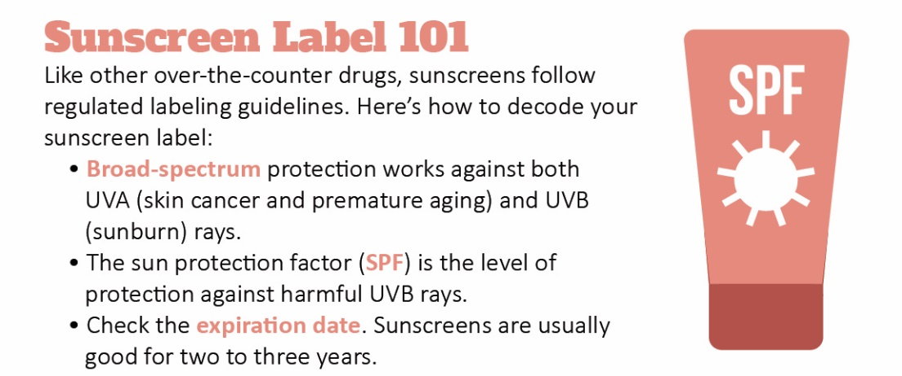
Routinely inspect your skin for any spots or changes in color or appearance. If you have any concerns, see your doctor.

Fast Food and Heart Health
Fast food is highly processed and contains unhealthy trans fats, especially when food items are fried in oil. Eating fried food may increase your risk for heart disease and stroke.
According to new research, people who ate the most fried food per week had a 28% higher risk of major cardiovascular events, compared with those who ate the least. Those people also had a 22% greater risk of heart disease—and a 37% elevated risk of heart failure.
Along with choosing baked or grilled items, consider the following heart-healthy alternatives to fried food:
- Skinless poultry and fish
- A variety of fruits and vegetables
- Low-fat dairy products
- Whole grains
Limit your daily intake of fast food, and talk to your doctor if you have questions.

