5 Ways to Start Your Year Off Right
Brought to you by Your Employer and Sullivan Benefits
Like many other people, you may be thinking about what you would like to accomplish in 2021 or what life changes you could make. Common New Year’s resolutions include losing weight, exercising, getting organized, learning new skills and saving money.
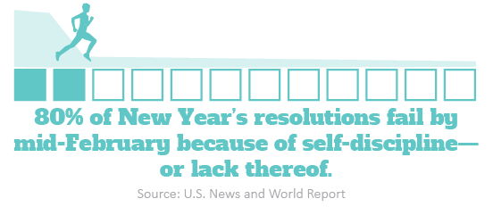
To achieve your resolutions, try the following strategies:
- Set a goal that motivates you.
- Set a goal that is specific.
- Set a goal that is manageable or attainable.
- Write down your goals to establish intention.
- Share your goals with others to increase accountability.
Ready, Set, Go!
2020 has likely given you time to reflect and think about what you’d like to change about your lifestyle. This is a good time to make positive life changes and strive for an overall healthier self. Consider the following five tips to start the new year off right:
- Check in on your mental health. Mental health is just as important as physical health in building a healthy lifestyle. Reach out to a professional if you need help.
- Be social. Isolating during the COVID-19 pandemic doesn’t have to mean loneliness. Reconnect with others virtually or while practicing social distancing.
- Get regular checkups. Stay up to date on your annual physicals and necessary health tests. Screenings can help identify health issues to be addressed.
- Drink more water. Consuming sugary drinks, like juice or soda, can cause liver damage, premature aging and anxiety. Avoid excessive alcohol consumption as well.
- Count nutrients, not calories. Focus on improving the overall quality of your diet and not getting hung up on calories. Achieve this by adding more fiber, protein and probiotics to your diet.
If you do just one thing in 2021, consider making time for yourself. Identify the activities that make you happy or fulfilled and prioritize them. Talk to your doctor or mental health professional for guidance and support with lifestyle changes.

Kick Stress Eating to the Curb
As the COVID-19 pandemic and winter season continue, you may be fighting the urge to eat your feelings. Although stress eating may be soothing at first, you likely won’t feel better in the end. Consuming excess calories in one sitting can cause fatigue, bloating, stomach discomfort and weight gain over time. Consider the following ways to cope with stress eating:
Makes: 5 servings
Ingredients
3 ½ pounds chicken
¼ tsp. salt
¼ tsp. black pepper
1 ½ garlic cloves (thinly sliced, or 1 tsp. garlic powder)
4 thyme sprigs (or 1 tsp. dried thyme)
3 cups onion (thinly sliced)
1 ½ cups chicken stock
¼ cup lemon juice
1 lemon (cut into 10 slices)

Preparations
- Skin chicken and cut into 10 pieces. Lay chicken pieces in a 11-by-13-inch baking pan.
- Combine seasonings (salt, pepper, garlic and thyme) and sprinkle over the chicken.
- Combine onions, chicken stock and lemon juice in a sauce pan. Heat mixture to a boil.
- Pour hot lemon mixture around the chicken.
- Top each chicken piece with a lemon slice.
- Bake at 400 F for 30 minutes.

Nutritional Information
(per serving)
Total calories | 261
Total fat | 5 g
Protein | 40 g
Sodium | 521 mg
Carbohydrates | 12 g
Dietary fiber | 2 g
Saturated fat | 1 g
Total sugars | 5 g

Source: U.S. Department of Agriculture (USDA)
- Indulge in moderation. Everything is OK in moderation, just don’t overdo it. Set yourself a limit before taking that first bite.
- Control portion sizes. On a similar note, make snacks easy to grab and go by pre-portioning them to help you save time and avoid overeating.
- Boost nutritional value. Introduce healthy swaps or additions to your favorite indulgences. For example, consider substituting pasta with zucchini noodles or adding healthy toppings to ice cream that you can fill up on instead.
- Choose “busy snacks.” Opt for healthy snacks that keep your hands busy, such as eating popcorn or dipping apple slices into peanut butter.
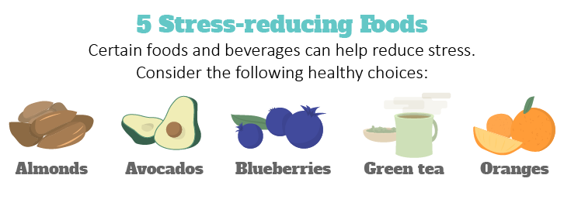
It could also be helpful to incorporate exercise or mindful activities into your routine for when you want to stress eat. It’s all about finding a strategy that works to help you feel better in the long run.

Don’t Forget, It’s National Blood Donor Month
Winter is one of the most difficult times of the year to collect enough blood products and donations to meet patient needs. That’s why National Blood Donor Month is celebrated every January. This month, resolve to be a blood donor and consider the following health benefits of donating blood regularly:
- Detects health problems—Donated blood is tested, so you can find out if any irregularities were found. You’re also required to undergo a quick health screening prior to giving blood.
- Reduces heart disease risks—Donating can help eliminate any excess buildup of iron in the blood, which can lower your risk for a heart attack.
- Burns calories—The blood donation process typically burns 650 calories.
Before you roll up your sleeve and commit to being a regular blood donor, check if you meet the American Red Cross’ requirements to safely donate blood.

