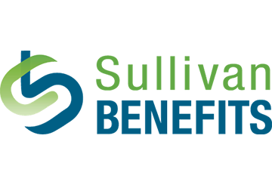
3 Ways to Boost Your Heart Health
Brought to you by
Heart disease continues to be the leading cause of death for both men and women in the United States. In fact, 1 in every 4 deaths is caused by heart disease.
Heart disease refers to several different types of heart conditions. Coronary artery disease—caused by plaque buildup in the walls of the heart’s arteries—is the most common. Other forms of heart disease include heart attack, heart failure, arrhythmia and congenital heart defects.
The symptoms of heart disease can vary, and some people may not even know they have a heart condition until they have a heart attack. Red flags include shortness of breath, chest discomfort, difficulty with speech, heart palpitations and sudden loss of responsiveness.
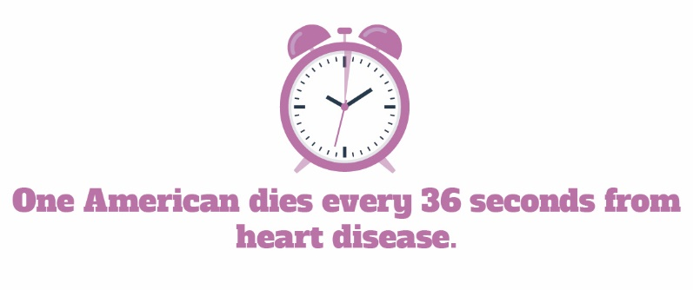

Take Control of Your Heart Health
There are certain uncontrollable factors that increase your risk of heart disease, including age, sex and family history. However, other factors that increase your risk for heart disease—such as stress, inactivity, obesity, diabetes, smoking and a poor diet—are controllable.
A healthy diet and lifestyle are your best methods to fight heart disease, so consider incorporating these three kinds of exercise into your routine to improve your heart health:
- Aerobic exercise improves circulation and can help your cardiac output. Try to get at least 30 minutes a day of heart-pumping moderate activity—like brisk walking, dancing or cycling—at least five days a week.
- Resistance training with weights, resistance bands or body weight at least two nonconsecutive days per week can help create leaner muscle mass. When paired with aerobic activity, you can raise your good cholesterol levels and lower bad cholesterol levels.
- Flexibility workouts, like stretching and balance, are critical for musculoskeletal health. It’s important to stay flexible and joint pain-free so you can maintain your regular aerobic and resistance workouts.
Keep in mind that it’s the overall pattern of your life choices that determines your heart health. Contact your doctor to find out your risk for heart disease, or for more information.

Dealing With Job Burnout During the Pandemic
Common job stressors include heavy workload, lack of work-life balance and job security concerns. If left unaddressed, burnout—which is chronic, unchecked stress—can have serious consequences for your health, social life and career. Burnout can also increase your risk of getting sick.
Makes: 6 servings
Ingredients
6 cups water
¼ cup fresh parsley (chopped, or 2 Tbsp. dried parsley)
2 tsp. beef bouillon
1 ½ cups lentils (dry)
2 medium carrots (sliced)
1 medium onion (chopped)
2 celery stalks (sliced)

Preparations
- Mix all ingredients together in a slow cooker.
- Cook on the low setting for 8-10 hours or on the high setting for 4-5 hours.
- Serve hot with crackers or bread.

Nutritional Information
(per serving)
Total calories | 175
Total fat | 1 g
Protein | 13 g
Sodium | 179 mg
Carbohydrates | 31 g
Dietary fiber | 12 g
Saturated fat | 0 g
Total sugars | 4 g

Source: MyPlate
Dealing with stress is a normal part of everyday life, and these uncertain times may be elevating your overall stress levels even more. Consider the following ways to cope with job burnout:
- Evaluate and discuss your options. Be open with your manager, and discuss job expectations or suggest taking on different responsibilities.
- Seek support. Talking with trusted co-workers, friends and family can help. Also, check if you have access to an employee assistance program.
- Try a relaxing activity. Explore mindful activities—like yoga, meditation or breathing exercises—to take a break and focus on how you’re feeling.
- Check in on your physical health. It’s important to get plenty of sleep to tackle each day. Create a plan to exercise more and eat healthier foods.
If all else fails, you may need a change of scenery. Start small by moving your remote workspace or, if possible, sitting in a different spot in the office. If you’re experiencing burnout, talk to your manager or mental health professional.
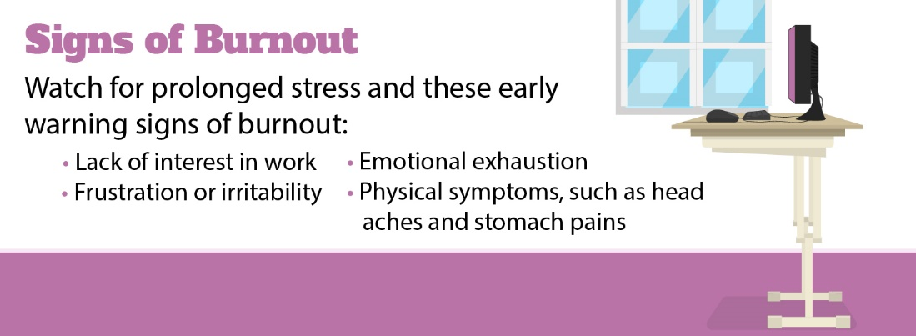

Don’t Delay Preventive Care
The once-a-year checkup has been considered a standard of health care, but many people may be putting off routine appointments during the pandemic. Preventive care allows health care providers to detect diseases or medical problems before they turn serious. Preventive care includes physical and mental health screenings, cancer screenings, annual checkups and immunizations.
Telemedicine makes it possible for you to talk to a doctor about your health, receive a prescription and obtain treatment recommendations from the comfort and safety of your home. Telemedicine shouldn’t be used for emergency care situations, but can be a great way to stay up to date on preventive care. Your physical and mental health are important, so don’t put it on the back burner.
While many major health plans cover telemedicine services, be sure to check your plan’s explanation of benefits to avoid any surprise costs.

