**Celebrating Holidays Safely During the COVID-19 Pandemic**

'Tis the season for holiday planning. Yet, gatherings of families and friends, crowded parties and travel may put Americans at an increased risk for COVID-19. The Centers for Disease Control and Prevention (CDC) recommends that you carefully consider the spread risk of in-person holiday celebrations.



Several factors contribute to COVID-19 spreading in group settings. Those include community spread of the coronavirus, event location, event duration, quantity of attendees and the locations where attendees are coming from. It’s also important to consider attendees’ behavior both prior to the gathering and during the celebration.

Before a Gathering

If you choose to attend an in-person event, consider the following tips prior to the gathering:

* Check whether the host has steps in place to prevent the spread of the coronavirus.
* Bring along supplies like extra masks, tissues and alcohol-based hand sanitizer.
* Avoid contact with people outside of your household for 14 days before the gathering.

Also, it’s important to stay home if you do not feel well or are at a higher risk for serious complications from COVID-19.

During a Gathering

Consider the following tips from the CDC to reduce your risk of being exposed to, contracting or spreading COVID-19 during an in-person event:

* Maintain a distance of at least 6 feet from people you don’t live with—and be mindful in areas where it may be harder to do so, such as restrooms and eating areas.
* Wear a mask at all times when around people who don’t live in your household.
* Limit contact with commonly touched surfaces or shared items.
* Wash your hands often with soap and water. If soap and water are not readily available, use a hand sanitizer that contains at least 60% alcohol.

If you want to celebrate the holidays as safely as possible this year, consider celebrating virtually or with members of your own household.

Brought to you by Sullivan Benefits

Give Your Holiday Baking Recipes a Makeover

Food is part of holiday traditions, and your family likely looks forward to certain recipes. Luckily, there are some simple substitutes to make your favorite holiday recipes a bit healthier.

Consider the following tips to transform your recipes without sacrificing flavor:

* **Fat—**For baked goods, use half the butter or oil and replace the other half with unsweetened applesauce or mashed banana.
* **Salt—**If baked goods don't require yeast, you can reduce salt by half.
* **Sugar—**Reduce the amount of sugar by one-third to one-half. Instead, add spices like cinnamon, cloves, allspice and nutmeg**—**or flavorings such as vanilla or almond extract to boost sweetness.

Get creative and experiment with other ways of creating healthy recipes for your most beloved holiday traditions.

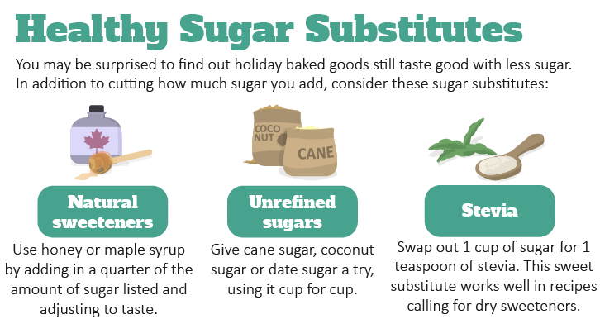

Makes: 4 servings

**Ingredients**

vegetable cooking spray

**1** acorn squash

**1** dash salt

**2** Tbsp. margarine

**3** Tbsp. brown sugar

**1** tsp. cinnamon

**¼** tsp. nutmeg

**¼** tsp. ginger

**Preparations**

1. Preheat oven to 400 F.
2. Coat the baking sheet with vegetable cooking spray.
3. Wash the squash. Cut it in half lengthwise and remove the seeds. Cut the squash into ½-inch slices.
4. Place the squash on the baking sheet. Sprinkle with salt.
5. Melt the margarine on low heat in a small saucepan.
6. Add brown sugar, cinnamon, nutmeg and ginger to the saucepan.
7. Spread the margarine mix on the squash.
8. Bake 20 to 25 minutes, or until tender.

**Nutritional Information**

**(per serving)**

|  |  |
| --- | --- |
| Total calories | 122 |
| Total fat | 6 g |
| Protein | 1 g |
| Sodium | 91 mg |
| Carbohydrates | 19 g |
| Dietary fiber | 2 g |
| Saturated fat | 1 g |
| Total sugars | 7 g |

Source: U.S. Department of Agriculture (USDA)

Are You Getting Enough Water?

To prevent dehydration, you need to consume adequate amounts of fluid. Dehydration can increase your risk of illnesses and cause health problems, such as fatigue and muscle weakness. According to new guidelines, men should get about 3.7 liters (15 ½ cups) of fluids each day, and women need about 2.7 liters (11 ½ cups). Remember that the water content of the foods you eat counts as well.

You need to get enough water for your body to operate at its best. Make water your beverage of choice, and consider these simple tips to help achieve your daily water intake:

* Drink a glass of water with each meal and between each meal.
* Hydrate before, during and after exercise.
* Carry a reusable water bottle with you for easy access during the day.
* Choose sparkling water instead of alcoholic drinks or soft drinks.