**Combating Pandemic Fatigue**

An unintentional phenomenon is on the rise—pandemic fatigue. People are tired of staying at home. People want to be the social creatures they inherently are. People want their “normal” back.

This collective fatigue is making some people—consciously or unconsciously—disregard pandemic guidance such as social distancing and mask wearing. Others may be reaching a mental health breaking point.



Alarming data from a U.S. Census Bureau survey revealed the psychological toll taken by the pandemic. American adults were asked typical mental health screening questions. Twenty-four percent showed clinically significant symptoms of major depressive disorder, and 30% showed symptoms of generalized anxiety disorder. Those rates were higher among younger adults (ages 18 to 29), women and people making less than $25,000 a year.

If you feel like you’re battling pandemic fatigue and losing self-discipline, stay the course with these coping tips:

* **Try a new exercise.** If you’ve been finding it harder to stay active, experiment with something new like walking, yoga or cycling.
* **Try meditation.** Mindful activities can help lower your stress levels and improve your mood.
* **Try saying it out loud.** Sometimes you just need to talk to someone about how you’re feeling, especially if you’re stressed, frustrated or anxious. Ignoring those strong feelings won’t make them go away.
* **Try new recipes.** You’ve likely already mastered the pandemic sourdough or banana bread, so roll up your sleeves and whip up something else. This is a good time to prepare healthier meals and use that time as a fun daily activity for you and your family.

Consider how you relaxed pre-pandemic, and try to get back to that lifestyle. If you find cooking, reading or listening to music relaxing, make time to keep that a part of your routine.

If you’re worried about your mental well-being, please contact your doctor.

Brought to you by Your Employer and Sullivan Benefits

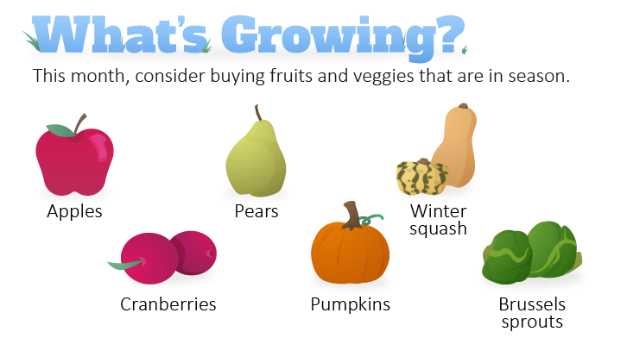

Benefits of Buying Seasonal Produce

In today’s market, it’s normal to see the same produce available year-round. However, that doesn’t mean the quality’s the same throughout the seasons. Eating seasonally means you are simply taking advantage of the harvest schedule and enjoying produce at its peak. For this time of year, that includes foods with rich fall colors like burnt orange, deep burgundy and hunter green.

Shop for seasonal produce and reap the following benefits:

* **Fresher food—**Seasonal produce likely is recently picked and hasn’t been sitting on a truck or in a warehouse for weeks.
* **Better taste—**In-season produce retains its nutritional value and tastes better, sweeter and perfectly ripe. If the produce is tasty, you’ll likely eat more of it. That’s a healthy win-win.
* **Lower costs—**When produce is in season, farmers harvest larger crops. The increased supply may mean lower prices for you.
* **Reduced carbon footprint—**Out-of-season produce is typically imported or takes more energy to grow due to the need for greenhouses.

It’s called harvest season for a reason, so there should be plenty of fresh produce options available at your local farmers market or grocery store.

How to Stay Physically Active

Due to social distancing and gym closures, it may be tougher to be active. People are home more and likely indulging in sedentary activities—like sitting, watching TV or spending time in front of other electronic devices.

Instead of binge-watching your favorite show, consider these tips for staying active:

* **Get moving.** Anything counts! Don’t focus on running or working out in a gym. Grocery shopping and cleaning the house count as exercise.
* **Go at your own pace.** Ease into exercise and slowly increase as you build up your stamina.
* **Listen to your body.** You know yourself best. If you start to feel dizzy or experience pain, stop and take a break.

Makes: 12 servings

**Ingredients**

**2** cups flour

**¾** cups sugar

**3** tsp. baking powder

**½** tsp. salt

**½** tsp. cinnamon

**¾** tsp. allspice

**⅓** cup vegetable oil

**2** eggs

**¾** cup pumpkin puree

**2** cups cranberries (chopped)

**Preparations**

1. Preheat oven to 400 F.
2. Sift dry ingredients together.
3. In a separate bowl, beat oil, eggs and pumpkin together until well blended.
4. Add the wet ingredients to the dry ingredients. Stir until moistened.
5. Fold in chopped cranberries.
6. Spoon into paper-lined muffin cups.
7. Bake for 15 to 30 minutes.

Nutritional Information

(per serving)

|  |  |
| --- | --- |
| Total calories | 204 |
| Total fat | 7 g |
| Protein | 3 g |
| Sodium | 255 mg |
| Carbohydrates | 32 g |
| Dietary fiber | 2 g |
| Saturated fat | 1 g |
| Total sugars | 14 g |

Source: U.S. Department of Agriculture (USDA)