**Why Cleaning Your Home  
Can Boost Overall Well-being**

Deep cleaning doesn’t need to be a one-season chore. Experts say doing a thorough cleaning of your home has a number of health benefits. A clean home can strengthen your immune system and help you avoid illnesses. A decluttered living space can also reduce stress and depression as well as help avoid injuries, like tripping.

According to the American Cleaning Institute (ACI), 74% of Americans do general surface-level cleaning more often than deep cleaning. That leaves 26% who deep clean their home on a regular basis, thoroughly cleaning the entire home and its floors, furniture and surfaces.

Bathrooms and kitchens are typically the rooms that get deep cleaned most often. Don’t forget about living rooms and bedrooms though. You spend time in those on a daily basis, so it’s worth giving them some special treatment as well. According to ACI survey results, 60% of people deep clean because they recognize their home needs a thorough cleaning. Other motives to deep clean on an annual basis include to remove clutter, to remove asthma or allergy triggers, and to prevent the spread of illness.  
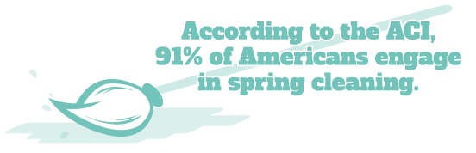

The Power of Cleanliness

Even if you already spring cleaned, consider the following health and well-being benefits from deep cleaning your home year-round:

* **Strengthen the immune system**—Dust, mold, mildew and pet dander can be allergy triggers.
* **Reduce stress and depression**—A clutter-free home has a positive effect on people’s daily mood and ability to focus. Organizing, tossing or donating can be mentally refreshing and liberating, too.
* **Sleep better**—With less stress comes better sleep. According to the National Sleep Foundation, people who make their beds every morning are 19% more likely to get a good night’s rest.
* **Prevent illness**—Keep surfaces clean to improve food safety and minimize the spread of harmful germs.
* **Boost productivity**—Clutter is distracting. Looking at too many things at once interferes with your brain’s ability to process information.

Boost your well-being today by dusting, vacuuming, washing and reorganizing. This is the perfect time to get your regular cleaning routine back on track.

Brought to you by: Your Employer and Sullivan Benefits

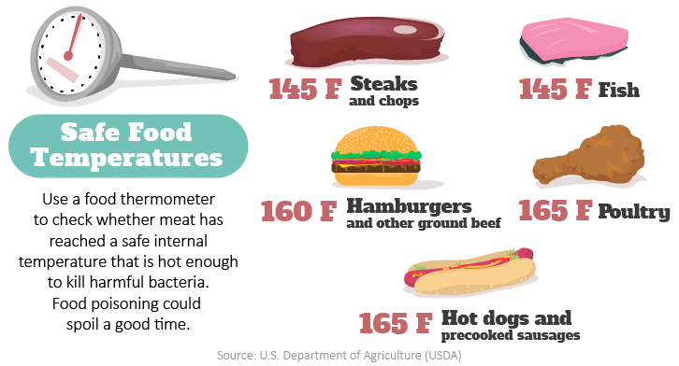

How to Reduce Your Food Waste

According to the U.S. Environmental Protection Agency, the average American produces about 219 pounds of food waste each year. Start small and consider the following tips to reduce your food waste:

* **Shop smart** to avoid buying more food than you need. Make a list of what you need and then stick to it.
* **Store food properly** by learning what should be refrigerated or kept at room temperature.
* **Keep your fridge organized** so you can see foods and know when they were purchased. Place newer packages behind old ones.
* **Save leftovers** in clear glass containers so you don’t forget about them.
* **Freeze food** to preserve leftovers, meats, soups, herbs or greens.
* **Understand expiration dates** to know the difference between “sell by,” “best by” and “use by” labels.

Grilling Safety Tips

As warmer weather hits, the smell of food on the grill fills the air. According to the National Fire Protection Association, nearly 9,000 home fires each year involve grills, so it’s important to brush up on barbecue safety. Consider the following grilling safety tips:

* Grill outside only. Don’t grill in a garage, porch or other enclosed space, even if it’s ventilated.
* Choose a safe location. Keep your grill on a flat surface at least 10 feet away from your house, garage or other structures.
* Check for leaks. Make it a habit to check the gas tank hose before using it for the first time each year.
* Never leave your grill unattended. Fires can double in size every minute.
* Keep children and pets at least 3 feet away from where food is being prepared or carried.
* Clean the grill regularly. Keep it clean by removing grease or fat buildup.

Makes: 4 servings

**Ingredients**  
**1** ripe avocado (cut into chunks)

**½** cup plain nonfat Greek yogurt

**4** tsp. lime juice

**½** cup blueberries

**½** cup carrots (grated)

**¼** cup red onion (chopped)

**2** cups fresh arugula (chopped)

**12** oz. cooked chicken breast (cubed)

**4** 8-inch whole-wheat tortillas

**Preparations**

1. In a medium bowl, mash half of the avocado chunks with yogurt and lime juice.
2. Add the remaining ingredients, including the rest of the avocado chunks. Mix gently.
3. Top each tortilla with ¼ of the filling mixture.
4. Roll up each tortilla and tuck in ends. Slice in half diagonally, securing with toothpicks, if needed.

**Nutritional Information**

**(per serving)**

|  |  |
| --- | --- |
| Total calories | 389 |
| Total fat | 13 g |
| Protein | 35 g |
| Carbohydrate | 32 g |
| Dietary fiber | 7 g |
| Saturated fat | 3 g |
| Total sugars | 6 g |

Source: USDA