**Insert Your Logo Here**

Association, going grocery shopping when you’re hungry can cause you to spend more money than you initially planned to and can increase the odds that you’ll buy unhealthy options.

* **Cook at home as often as possible**. Many foods prepared at home are cheaper and more nutritious than fast food. Go back to the basics and find a few simple and healthy recipes that your family enjoys.

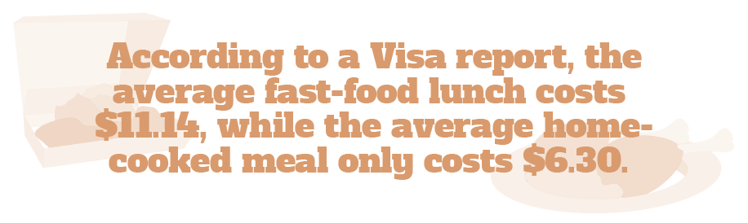

* **Buy in bulk**. For healthy, nonperishable items, it might be more cost-effective to purchase them in bulk. While the initial cost may be more expensive, doing so could help you save money in the long-run.
* **Shop seasonally**. Fresh fruits and vegetables are usually easier to find and may be a lot less expensive when purchased in season.

Eating Healthy Doesn’t Have to Be Expensive

Eating a well-balanced diet is a key component of living a long, healthy life. Many Americans think that eating healthy means they have to empty their wallets, which isn’t necessarily the truth. Keep the following money-saving tips in mind next time you’re grocery shopping:

* **Make a weekly meal plan**. Before you go to the store, think about what meals and snacks you want for the week. Read recipes thoroughly so you can make an accurate list of everything you need, reducing the risk that you’ll have to run back to the store later in the week.
* **Create a list—and stick to it**. Make a detailed list of what you need to buy before you go to the store. When you get to the store, don’t buy anything besides what’s on the list.
* **Plan where you’re going to shop**. Many grocery stores run sales or offer coupons for various healthy foods. Check out the ads and plan your grocery list around what’s on sale.
* **Don’t go grocery shopping when you’re hungry**. According to the Journal of the American Medical

Brought to you by: Your Employer and Sullivan Benefits

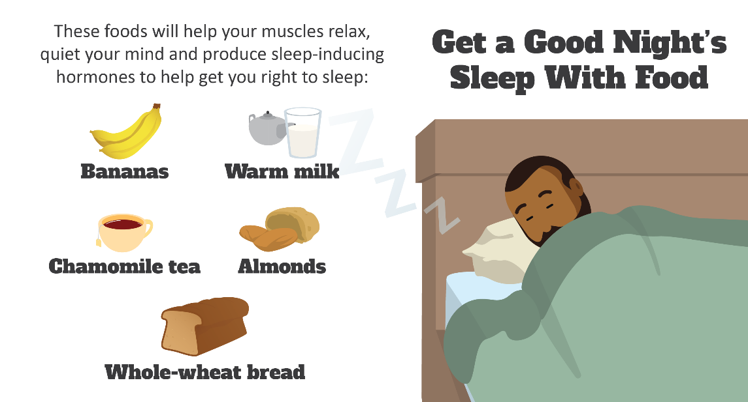

Experts Are Warning of Another Bad Flu Season

Although it’s just a few months into flu season, experts are warning of another bad season. At the end of December 2019, health departments from 46 states were reporting “widespread” flu activity. Additionally, the CDC revealed that the number of patients with flu symptoms was almost as high as the peak of the historic and deadly 2017-18 flu season.

Based on this early flu activity, public health experts are predicting heightened mid- to late-season activity as well. As such, experts are urging the public to take proper prevention measures, which include:

* Getting the flu vaccine
* Washing your hands often with soap and water
* Avoiding contact with those who are sick and staying home when you feel under the weather

5 Sleep Habits You Need to Adopt

The Centers for Disease Control and Prevention (CDC) has linked insufficient sleep to the development of chronic diseases and conditions, including diabetes, heart disease, obesity and depression. In honor of World Sleep Day, which is March 13, try adopting the following five healthy sleep habits:

1. Keep a regular schedule—try to go to bed and wake up at the same time each day, including weekends.
2. Create a good sleep environment, including a comfortable room temperature, minimal noise and sufficient darkness.
3. Keep track of habits that help you fall asleep, like listening to relaxing music or reading before bed. Repeat those activities each night.
4. Avoid caffeine and nicotine three to four hours before going to bed.
5. Limit alcohol before bed, as it can reduce sleep quality.

Makes: 5 servings

**Ingredients**  
**1** cup lentils (rinsed)

**¾** cup water

**½** tsp. salt

**¼** tsp. ground black pepper

**½** cup onion (chopped)

**¼** tsp. garlic powder

**1** can tomatoes

**2** carrots (thinly sliced)

**½** cup cheddar cheese (shredded)

**Preparations**

1. Combine lentils, water, seasonings, onion and tomatoes in a 2-quart casserole dish. Cover tightly with lid or foil.
2. Bake at 350 F for 30 minutes.
3. Remove from oven and add carrots. Stir.
4. Cover and bake 30 minutes longer.
5. Remove cover and sprinkle cheese on top.
6. Bake, uncovered 5 minutes, until cheese melts.

**Nutritional Information**

**(per serving)**

|  |  |
| --- | --- |
| Total calories | 200 |
| Total fat | 4 g |
| Protein | 14 g |
| Carbohydrate | 29 g |
| Dietary fiber | 11 g |
| Saturated fat | 2 g |
| Sodium | 418 mg |
| Total sugars | 6 g |

Source: USDA