* **Increase the amount of sleep you get**—One of the best ways to become healthier is to get enough sleep. Try to get at least seven hours of sleep, the expert-recommended amount, per night.



Set Yourself Up for Success

According to U.S. News & World Report, 80% of New Year’s resolutions fail. That’s why it’s so important to set yourself up for success when you’re choosing a resolution.

Regardless of what you choose as your New Year’s resolution, make sure it is a “SMART” goal—one that is specific, measurable, attainable, realistic and timely—to increase the odds that you will stick to it.

Don’t Fall Into This New Year’s Resolution Trap

Historically, one of the top New Year’s resolutions is to lose weight. Unfortunately, many people look to fad diets and weight loss products to achieve their goals quickly. While fad diets may prove effective initially, research shows that many people don’t find long-term success with these types of diets.

Lasting Lifestyle Changes vs. Quick Fixes

Instead of setting a goal to lose weight fast this New Year’s, set a goal to lead a healthier lifestyle. Common lifestyle New Year’s resolutions include the following:

* **Exercise regularly**—Aim to get at least 150 minutes of moderate aerobic activity or 75 minutes of vigorous aerobic activity a week, and to do strength training exercises of major muscle groups at least twice a week.
* **Maintain a well-balanced, healthy diet**—Try to eat a variety of fruits, vegetables, whole grains, protein-rich foods and healthy fats. Make it a goal to incorporate more fruits and veggies into your diet.

Brought to you by: Your Employer and Sullivan Benefits

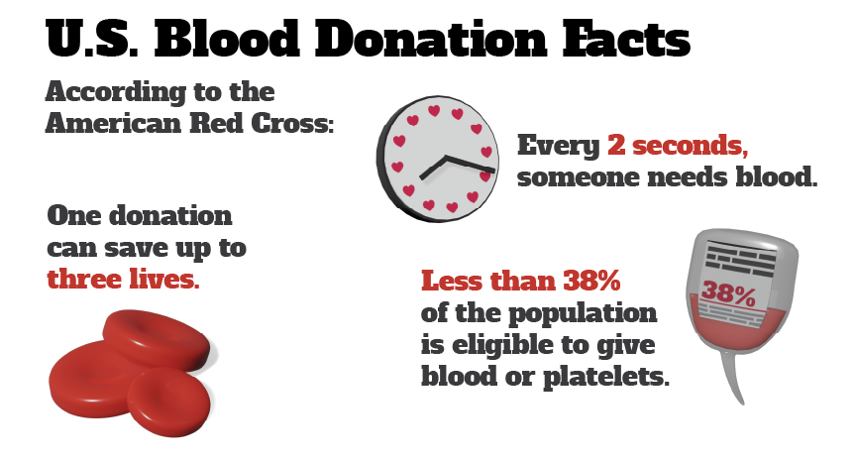

It’s National Blood Donor Month

Since 1970, National Blood Donor Month has been celebrated in January. Historically, the winter season is one of the most difficult times of the year to collect enough blood products and donations to meet patient needs. While “whole blood” donations are the most common, individuals can also make platelet, power red and plasma donations.

Donated blood is used for blood transfusions. Common scenarios in which blood transfusions are needed include the following:

* Patients suffering from severe trauma following disasters and accidents
* Patients receiving surgical treatments and some medical treatments, including cancer patients and patients with sickle cell disease

Making the decision to donate blood can help save a life, but not everyone is eligible to donate blood. Visit the American Red Cross’ [website](http://www.redcrossblood.org/donating-blood/eligibility-requirements) to see if you meet the requirements to safely donate blood.

This Superfood May Help Prevent Diabetes

According to a four-year [study](https://www.ncbi.nlm.nih.gov/pubmed/28392166), consuming legumes (e.g., beans, lentils and peas) may help you prevent diabetes. The study tracked the health of over 3,300 patients who were at-risk of developing Type 2 diabetes, and found that those who consumed the most legumes were 35% less likely to develop diabetes.

The weekly legume serving average varied between 3.35 servings and less than half a serving. The study found that those who ate just one serving per week were 33% less likely to develop Type 2 diabetes than those who consumed less than one serving per week.

In addition to helping prevent Type 2 diabetes, legumes can help protect heart and brain health, promote a healthy weight and reduce the risk of cancer. For more information, contact your doctor.

Makes: 6 servings

**Ingredients**  
**3** pounds chicken pieces (skin removed)

**2** cups tomatoes (chopped)

**1** clove garlic (minced)

**½** cup onion (chopped)

**¼** cup mild canned chilies (diced)

**2** cups canned pinto or garbanzo beans (drained)

**Preparations**

1. Place chicken pieces in a large saucepan and add enough water to cover.
2. Cook until tender, about 25 minutes.
3. Remove chicken pieces from the broth.
4. Add tomatoes, garlic, onion and chilies.
5. Remove chicken meat from the bones and return meat to broth.
6. Add beans, and salt and pepper to taste. Simmer for about 15 minutes.

**Nutritional Information**

**(per serving)**

|  |  |
| --- | --- |
| Total calories | 390 |
| Total fat | 14 g |
| Protein | 49 g |
| Carbohydrate | 16 g |
| Dietary fiber | 5 g |
| Saturated fat | 4 g |
| Sodium | 460 mg |
| Total sugars | 2 g |