UBA |  |  | WellnessWorksS | Your Logo Here
October 2019
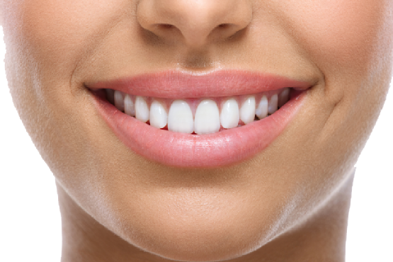  Dental Care: Oral Health and Wellness  There is a strong relationship between your oral health and general health. Did you know that poor oral health can lead to many seemingly unrelated medical conditions? In fact, oral bacteria and oral disease have been linked to a variety of serious illnesses, including heart disease, diabetes, stroke and pregnancy complications.  Importance of Oral Health  The following examples illustrate the relationship between your oral health and general health:  - Tobacco, alcohol and illicit drugs affect both your overall and oral health.  - Dry mouth, or a lack of saliva, increases your risk of tooth decay.  - Oral pain resulting in an inability to eat properly can prevent you from getting the nutrition your body needs to stay.  Periodontal Disease  Oral health can often be used to diagnose underlying health issues:  - The advanced form of gum disease, called periodontitis, causes tooth loss and is also sometimes associated with cardiovascular disease, stroke and bacterial pneumonia.  - Diabetics are more likely to develop periodontitis, and more severe cases of it. |  |  |  |  | Quick Takes  QuickTakes  Real-world time management  The smartphone era hasn't made time move any faster. But it can sure feel that way sometimes. Technology can make things easier but it can also suck up our time and increase stress. Set some ground rules for yourself.  - Log the number of minutes you spend on social media.  - Put away your phone while driving, at meals, and when trying to sleep.  - Set aside time to get active. You'll be paid back with more energy!  This month's newsletter takes a look at strategies to help you make the most of your time.  QuickTakes  Real-world time management  The smartphone era hasn't made time move any faster. But it can sure feel that way sometimes. Technology can make things easier but it can also suck up our time and increase stress. Set some ground rules for yourself.  - Log the number of minutes you spend on social media.  - Put away your phone while driving, at meals, and when trying to sleep.  - Set aside time to get active. You'll be paid back with more energy!  This month's newsletter takes a look at strategies to help you make the most of your time.  QuickTakes  Real-world time management  The smartphone era hasn't made time move any faster. But it can sure feel that way sometimes. Technology can make things easier but it can also suck up our time and increase stress. Set some ground rules for yourself.  - Log the number of minutes you spend on social media.  - Put away your phone while driving, at meals, and when trying to sleep.  - Set aside time to get active. You'll be paid back with more energy!  This month's newsletter takes a look at strategies to help you make the most of your time.  QuickTakes
Smart Trick-or-Treat Giveaways
Gone are the days when parents would normally bake and prepare food snacks that are a little more health conscious. In place of homemade goods, provide pre- packaged treats that are sanitary, safe and easy to pass along to the kids. Here is a list to keep handy when you are doing your holiday shopping.
Edible treats:
- Small boxes of raisins, cranberries and other dried fruits in their own packaging.
- Individual packages of trail mix.
- Small packages of potato chips and pretzels.
- Little boxes of animal crackers.
- 100-calorie packages of cookies, chips and crackers (baked and low-fat).
- Juice boxes, 100 percent juice.
- Sugarless chewing gum.
- Low-sugar fruit leather.
- Packaged cheese and crackers or peanut butter crackers.
When you return home from trick-or-treating, make sure to go through your child's Halloween bag to search for unwrapped edibles, items that may not be safe and toys that are not age-appropriate. Also, if your child has an allergy, check the labels of each item.
Be unique on your block this year by passing out smart treats!
United Benefit Advisors | 20 N. Wacker Drive, Suite 500 Chicago, IL 60606 | www.ubabenefits.com
WellnessWorksS

UBA
What This Means to You
Given the potential link between periodontitis and systemic health problems, preventing periodontitis may turn out to be an important step in maintaining your overall health. In most cases, this can be accomplished by practicing good daily oral hygiene, including brushing and flossing and regular seeing a dentist for cleanings. Tell your dentist about changes in your oral health, including any recent illnesses or chronic conditions.
Also provide your dentist with an updated health history, including medication you use; both prescription and over-the-counter. If you smoke, talk to your dentist about options for quitting.

Sources:
Zywave (Accessed 9/20/18)
https://www.colgate.com/en-us/oral-health/basics/nutrition-and-oral-health/prevent-tooth-decay-with-halloween-candy-alternatives-1013
 |  | Baked Apples & Sweet Potatoes Makes 6 servings
 | INGREDIENTS  5 sweet potatoes (cooked, nearly tender)  4 apples (cored, sliced)  ½ cup brown sugar  ½ tsp. salt  ¼ cup margarine  1 tsp. nutmeg  ¼ cup hot water  1 Tbsp. honey  DIRECTIONS  Ingredient Tip: Roast onions to bring out sweetness.  - Heat the oven to 400 F. Grease a casserole dish with butter  or margarine.  - Slice the apples and sweet potatoes.  - Layer the dish with sweet potatoes, apple slices, and some brown sugar, salt and margarine pieces (in that order). Repeat this layer pattern until the dish is filled.  - Sprinkle top layer with the remaining brown sugar, margarine and nutmeg.  - Mix hot water and honey, then pour the mix over the top layer. Bake for about 30 minutes. |  |  |  |  | NUTRITIONAL  INFORMATION  300 Calories  2 g Protein  8 g Fat  2 g Saturated fat  60 g Carbohydrate  6 g Fiber  320 mg Sodium
 | This newsletter contains general health information and is not a substitute for your doctor’s care. You should consult an appropriate health care professional for your specific needs. Some treatments mentioned in this newsletter may not be covered by your health plan. Please refer to your benefit plan documents for information about coverage.

