UBA | WellnessWorksS | Your Logo Here
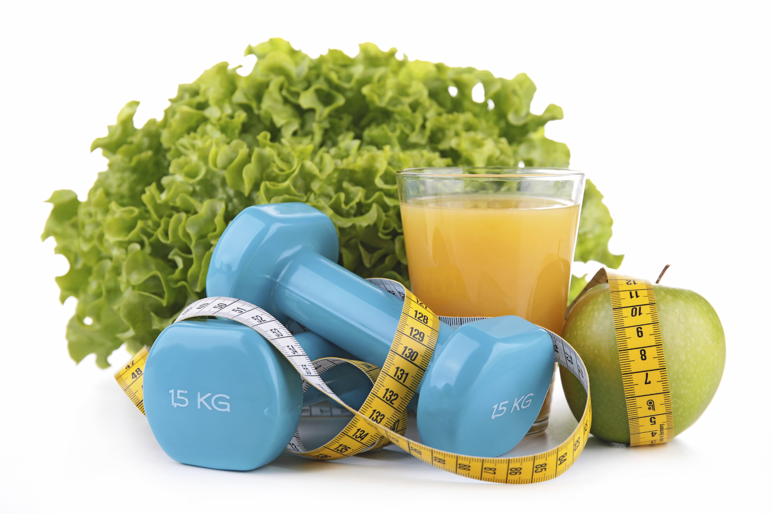
September 2019
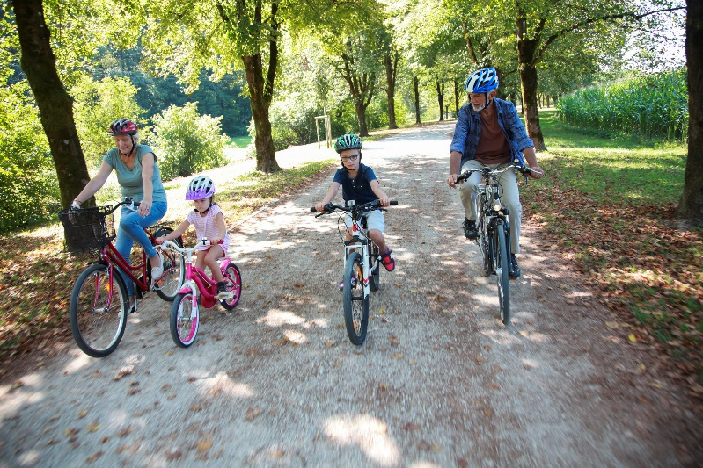  Family Fun  The family that plays together… has more fun! Well, that might depend somewhat on your family relationships, of course. But regardless of how competitive or harmonious your family is, getting active together is good for the health of everyone involved.  “But my family is so busy! There’s no time to get together to do something active together!” We hear you. Between jobs, school, homework, housework, and just-plain-life, finding the time is definitely challenging. But when you understand just how important it is for everyone to get the recommended amount of exercise for optimal health, you may feel more motivated to make it a priority Physical activity is good for kids’ hearts, bones, mental health and more. For adults, it can help prevent some cancers and stroke and improve overall quality of life — and much more.  Check out these ideas for how to rally the family troops and get moving:  - Get it on the schedule. Find a time that works for everyone, as often during the week as possible. Make it as set-in-stone as any other commitment on the family calendar.  - Be a role model. Your kids want to spend time with you, so having them join you in something physical kills two birds with one stone.  - Challenge your kids to some basketball, softball or backyard games.  - For a special treat, how about bowling, miniature golf, or a swim at a local pool or beach? |  |  | Quick Takes  QuickTakes  Real-world time management  The smartphone era hasn't made time move any faster. But it can sure feel that way sometimes. Technology can make things easier but it can also suck up our time and increase stress. Set some ground rules for yourself.  - Log the number of minutes you spend on social media.  - Put away your phone while driving, at meals, and when trying to sleep.  - Set aside time to get active. You'll be paid back with more energy!  This month's newsletter takes a look at strategies to help you make the most of your time.  QuickTakes  Real-world time management  The smartphone era hasn't made time move any faster. But it can sure feel that way sometimes. Technology can make things easier but it can also suck up our time and increase stress. Set some ground rules for yourself.  - Log the number of minutes you spend on social media.  - Put away your phone while driving, at meals, and when trying to sleep.  - Set aside time to get active. You'll be paid back with more energy!  This month's newsletter takes a look at strategies to help you make the most of your time.  QuickTakes  Real-world time management  The smartphone era hasn't made time move any faster. But it can sure feel that way sometimes. Technology can make things easier but it can also suck up our time and increase stress. Set some ground rules for yourself.  - Log the number of minutes you spend on social media.  - Put away your phone while driving, at meals, and when trying to sleep.  - Set aside time to get active. You'll be paid back with more energy!  This month's newsletter takes a look at strategies to help you make the most of your time.  QuickTakes
Is fitness more fun with friends?
If working out by yourself makes you feel sad and lonesome, or if the only voice urging you to get up and exercise is your own and you’re ignoring the message, it could be that working out alone just isn’t for you.
Being physically active on a solo basis is perfectly acceptable, of course. As long as you stay motivated to keep it up. If you’re your own best workout buddy, go for it! For some people, being active is more fun and more motivating when it’s done with other people.
Having a standing workout date with a friend or a group workout class can help you stay accountable. Your classmates can support you when the going gets tough. They can also cheer you on if you reach a particular goal or master a new move. Classes are also a great way to meet new people and develop new friendships. What’s important is getting at least 150 minutes per week of moderate-intensity activity, plus muscle-strengthening exercises at least twice per week. More is better, but less is good, too — any amount of activity is better than none.
And don’t forget about family when looking for physical-activity partners. Kids need exercise, too. You can help set a great example by encouraging activity and doing it together. For more ideas on activities for the whole family, read this month’s newsletter.
United Benefit Advisors | 20 N. Wacker Drive, Suite 500 Chicago, IL 60606 | www.ubabenefits.com

WellnessWorksS

UBA
- It’s recommended by experts that kids should spend two hours max screen time per day. Get them up and moving instead!
- Try some outdoor exploration. State or county parks (or even local city parks) usually have wonderful hiking trails and bike paths. Point out the different species of trees, insects and animals for a real learning experience.
- Turn on some music and dance. Just do your thing, or pop in a fitness-dancing CD and follow the leader.
- Encourage video games that require physical participation.
- Take some lessons or an all-ages class together — maybe tennis, swimming or yoga. Check out local resources like community ed or park board programs, or your local Y.
- Take to the water via canoe, kayak or paddleboard (wear life jackets!).
- Make it fun so that everyone looks forward to the time together.
Strengthen your family ties while everyone strengthens their commitment to staying active!
Talk with your doctor before significantly increasing your activity level. Ask about the amounts and types of activities that may be best for you. If you’re pregnant, talk with your doctor before beginning an exercise program, continuing your current routine or increasing your level of activity. Keep in mind, a doctor’s advice on physical activity may change as a woman gets further along in pregnancy. Be sure to discuss what type and what level of activity and exercise is safe for you during your pregnancy.
Sources:
Choosemyplate.gov. 10 tips: Be an active family. choosemyplate.gov/ten-tips-be-an-active-family (Accessed 7/8/19)
Health.gov. Physical activity guidelines for Americans, Second Edition. Top 10 things to know about the 2nd edition of the physical activity
guidelines for Americans. health.gov/paguidelines/second-edition/10things (Accessed 7/8/19)
American Heart Association. Limit screen time and get your kids (and the whole family) moving. heart.org/en/healthy-living/fitness/gettingactive/limit-screen-time-and-get-your-kids-and-the-whole-family-moving (Accessed 7/8/19)
American Heart Association. How to get your family active. heart.org/en/healthy-living/fitness/getting-active/how-to-get-your-family-active
(Accessed 7/9/19)
Familydoctor.org. Physical activity: Creating a family plan. familydoctor.org/physical-activity-creating-family-plan (Accessed 7/8/19)
 |  | Waldorf Salad Makes 4 to 6 servings
 | The Waldorf salad isn’t quite like Mom’s. It’s much lower in fat, thanks to light mayonnaise and nonfat buttermilk in the dressing. Toasting the walnuts in the oven or on the stovetop for a few minutes heightens their flavor and allows you to get away with using a smaller amount.  Takes 30-60 minutes.  INGREDIENTS  3 large Cortland, Gala, Braeburn or Granny Smith apples  2 teaspoons fresh lemon juice  1 ½ cups (8 oz/240 g) seedless green grapes, sliced in half  2 celery stalks, tough strings removed, stalks thinly sliced  1/3 cup (1 ½ oz/45 g) raisins  1/2 cup (4 oz/120 g) light mayonnaise  1/2 cup (4 fl oz/120 ml) nonfat buttermilk  2 teaspoons sugar  3 tablespoons crumbled blue or feta cheese  2 tablespoons toasted walnuts, finely chopped |  | 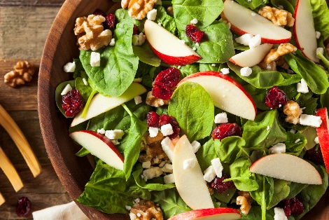  NUTRITIONAL INFORMATION  270 Calories 44 g Carbohydrate  3 g Protein 5 g Fiber  11 g Fat 220 mg Sodium  2 g Saturated fat 60 mg Calcium
DIRECTIONS
- Dice apples and toss with lemon juice in a large bowl. Add grapes, celery and raisins.
- In a small bowl, whisk mayonnaise, buttermilk, sugar and blue cheese, if using. Stir well and pour over apple mixture. Toss to mix.
- Cover and refrigerate for at least 30 minutes before serving.
- Sprinkle with toasted walnuts and serve.
 | This newsletter contains general health information and is not a substitute for your doctor’s care. You should consult an appropriate health care professional for your specific needs. Some treatments mentioned in this newsletter may not be covered by your health plan. Please refer to your benefit plan documents for information about coverage.

