UBA | WellnessWorksS | Your Logo Here
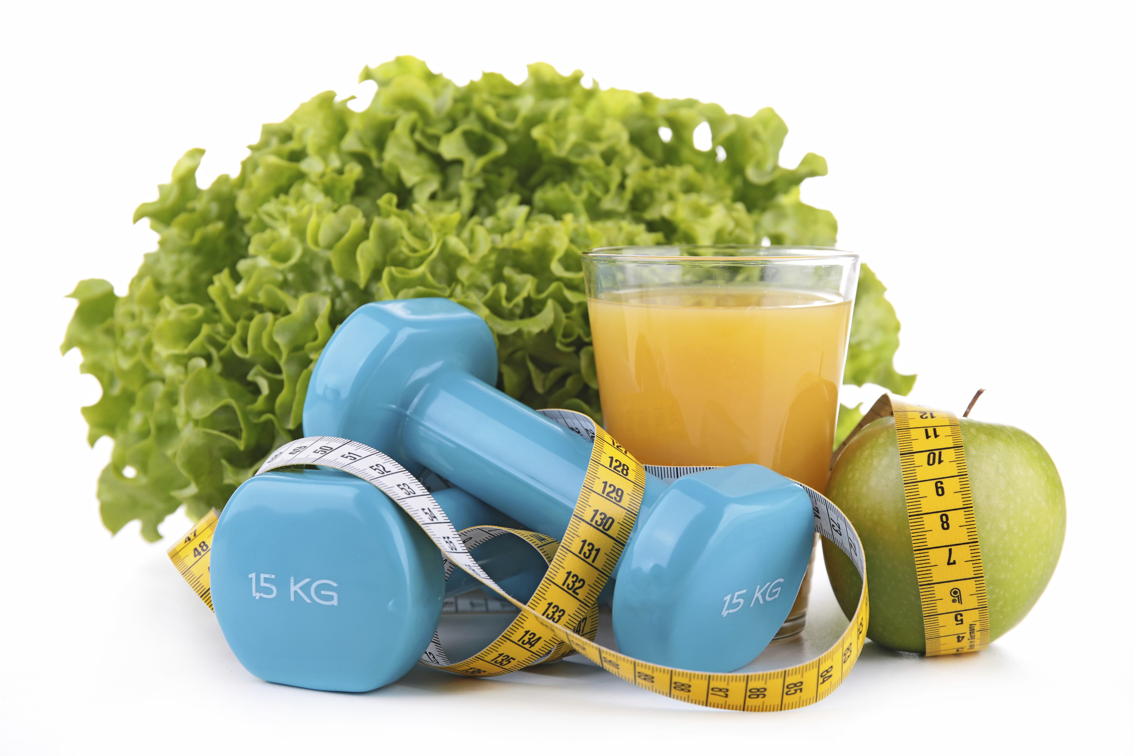
August 2019
The “Official” Lowdown on Physical Activity  You can read fitness magazines or online blogs, get tips from friends and neighbors, or make up your own rules and regimens for staying active. But when the federal government speaks, you should probably listen.  The Physical Activity Guidelines for Americans is the voice of authority when it comes to physical activity and health. The guidelines are based on scientific evidence and provide recommendations for Americans of all ages. The second edition of these guidelines came out in 2018 and includes some intriguing facts:  - About half of all American adults have at least one chronic disease.  - Seventy percent of the most common of these diseases can be improved by physical activity.  - A full 80 percent of adults aren’t getting the aerobic and muscle-strengthening activity recommended.  - This lack of activity has been linked to 10 percent of premature deaths.  Yikes! Not good, right? If this gets your attention and you’d like to up your activity level, here are the top recommenda-tions from the guide:  - Kids ages 3 - 5 should be active at least 3 hours a day. |  |  | Quick Takes  QuickTakes  Real-world time management  The smartphone era hasn't made time move any faster. But it can sure feel that way sometimes. Technology can make things easier but it can also suck up our time and increase stress. Set some ground rules for yourself.  - Log the number of minutes you spend on social media.  - Put away your phone while driving, at meals, and when trying to sleep.  - Set aside time to get active. You'll be paid back with more energy!  This month's newsletter takes a look at strategies to help you make the most of your time.  QuickTakes  Real-world time management  The smartphone era hasn't made time move any faster. But it can sure feel that way sometimes. Technology can make things easier but it can also suck up our time and increase stress. Set some ground rules for yourself.  - Log the number of minutes you spend on social media.  - Put away your phone while driving, at meals, and when trying to sleep.  - Set aside time to get active. You'll be paid back with more energy!  This month's newsletter takes a look at strategies to help you make the most of your time.  QuickTakes  Real-world time management  The smartphone era hasn't made time move any faster. But it can sure feel that way sometimes. Technology can make things easier but it can also suck up our time and increase stress. Set some ground rules for yourself.  - Log the number of minutes you spend on social media.  - Put away your phone while driving, at meals, and when trying to sleep.  - Set aside time to get active. You'll be paid back with more energy!  This month's newsletter takes a look at strategies to help you make the most of your time.  QuickTakes
Making fitness work
Do you have a desk job, or some other kind of job that has you sitting most of the day? Once seated, are you prone to staying seated for hours at a time? It’s understandable: you have a job to do. You’ve got to concentrate, you’ve got to meet that deadline, answer those emails, and write those memos. You let your fingers do the walking — not your feet.
Along with the “fanny fatigue” that results from sitting all day, this lack of movement could lead to health issues — and even, ultimately, death from a number of conditions. When you move more, however, you can help lower the risk of conditions such as diabetes, heart disease, and high blood pressure.
The solution? Learn how you can get moving at work! Park farther away from your building. Walk to your co-workers’ desks rather than emailing or phoning. Do a few stretches, walk the corridors, and use the stairs instead of the elevator.
For information on just how much physical activity the Department of Health and Human Services recommends, read on!
United Benefit Advisors | 20 N. Wacker Drive, Suite 500 Chicago, IL 60606 | www.ubabenefits.com

WellnessWorksS

UBA
- Kids 6 - 17 should strive for at least an hour of moderate to vigorous activity per day. This should include aerobic activity (anything that speeds up heart rate) and muscle-strengthening activities. This activity has been shown to help with things like bone health, heart health and even learning.
- Adults need at least 150 to 300 minutes of moderate-intensity activity per week and at least two days of muscle-strengthening activity (lifting weights, push-ups). Physical activity brings immediate health benefits, like lowering blood pressure and improving sleep. Over time, physical activity can lower the risk of heart disease, diabetes, dementia, weight gain, and eight different cancers, among other health risks. It also helps improve overall quality of life.
- For people who already have a health condition, physical activity can help with pain, slow the disease’s progress, keep depression and anxiety at bay, and improve brain function for people with Alzheimer’s disease, MS, Parkinson’s, and other conditions.
When it comes to government, you might not like everything you hear and read. But for the real scoop on activity levels and health, our friends in Washington seem to know what’s best. Remember, any activity is better than none, so get out of your chair, step away from your desk, or otherwise get moving!
Source:
Health.gov. Physical activity guidelines for Americans, 2nd edition. health.gov/paguidelines/second-edition/10things (Accessed 6/20/19)
 |  | Corn-off-the-Cob Salad Makes 4 cups, for 4 servings
 | If fresh corn isn’t in season, substitute 3 ½ cups frozen corn kernels in this salad.  Takes 30-60 minutes.  INGREDIENTS  4 ears fresh sweet corn, shucked  ½ cup (4 fl oz/120 ml) low-fat or nonfat buttermilk  2 tablespoons fresh lemon juice  2 tablespoons minced fresh parsley  2 tablespoons snipped chives  1 tablespoon chopped basil  1 clove garlic, minced  Sea salt to taste  Freshly ground black pepper to taste  1 green or red bell pepper, cut into small pieces  DIRECTIONS  Ingredient Tip: Roast onions to bring out sweetness.  - Bring a large pot of water to a boil. Immerse corn in water and cook for one minute.  - Drain and refresh under cold running water. Use a serrated knife to cut kernels from the cobs.  - In a mixing bowl, whisk together buttermilk, lemon juice, parsley, chives, basil, garlic, salt and pepper.  - Add the corn kernels and diced green or red pepper. Stir to coat.  - Refrigerate at least 30 minutes to allow flavors to blend. |  | NUTRITIONAL  INFORMATION  105 Calories  4 g Protein  1.3 g Fat  0.3 g Saturated fat  23 g Carbohydrate  2.7 g Fiber  47 mg Sodium
 | This newsletter contains general health information and is not a substitute for your doctor’s care. You should consult an appropriate health care professional for your specific needs. Some treatments mentioned in this newsletter may not be covered by your health plan. Please refer to your benefit plan documents for information about coverage.

