UBA | WellnessWorksS | Your Logo Here
July 2019
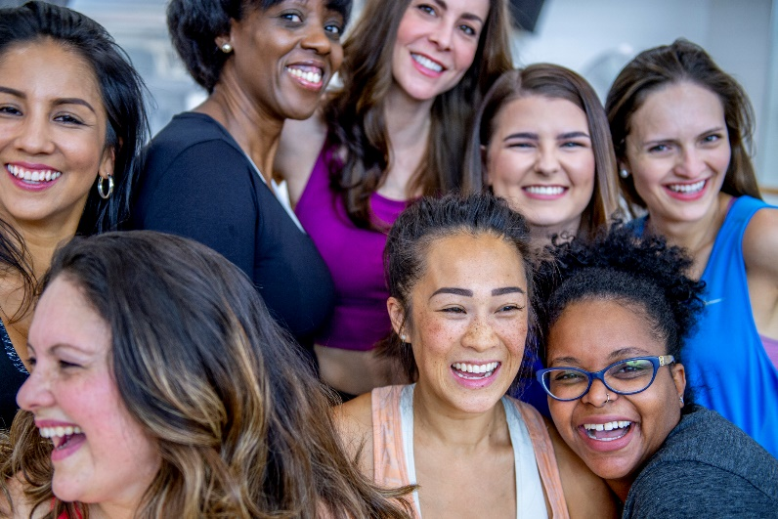  Making new friends  Maybe you’ve just changed jobs or you’re the new kid on the block. Maybe you’d just like to widen your horizons — and your social circle. Or maybe you’re just naturally shy and hesitant to put yourself out there. If, for whatever reason, you’d like to meet new people and develop new friendships, but you’re not sure where to begin, never fear. Check out these ideas for where and how to connect (and reconnect!) with people. It starts with an open mind — and a ready smile.  Volunteer – Giving of your time is both fulfilling and a great way to meet like-minded people.  Be a joiner – If your budget allows, join a local fitness center or yoga studio. Get fit and get to know people in one fell swoop.  Expand your knowledge – Community education programs and local colleges offer a huge variety of classes, from academics to belly dancing to woodworking. Check out what’s available in your area.  Find a book club – Ask around to see if there’s a book club you could join or check with your local library. Bonding with other bookworms is a great way to connect (even if you don’t finish the book!).  Hit the dog park – Dog people love to talk to other dog people. Go often enough and you may start seeing familiar faces, human and canine. There’s great friendship potential there for you and your doggie! |  |  | Quick Takes  QuickTakes  Real-world time management  The smartphone era hasn't made time move any faster. But it can sure feel that way sometimes. Technology can make things easier but it can also suck up our time and increase stress. Set some ground rules for yourself.  - Log the number of minutes you spend on social media.  - Put away your phone while driving, at meals, and when trying to sleep.  - Set aside time to get active. You'll be paid back with more energy!  This month's newsletter takes a look at strategies to help you make the most of your time.  QuickTakes  Real-world time management  The smartphone era hasn't made time move any faster. But it can sure feel that way sometimes. Technology can make things easier but it can also suck up our time and increase stress. Set some ground rules for yourself.  - Log the number of minutes you spend on social media.  - Put away your phone while driving, at meals, and when trying to sleep.  - Set aside time to get active. You'll be paid back with more energy!  This month's newsletter takes a look at strategies to help you make the most of your time.  QuickTakes  Real-world time management  The smartphone era hasn't made time move any faster. But it can sure feel that way sometimes. Technology can make things easier but it can also suck up our time and increase stress. Set some ground rules for yourself.  - Log the number of minutes you spend on social media.  - Put away your phone while driving, at meals, and when trying to sleep.  - Set aside time to get active. You'll be paid back with more energy!  This month's newsletter takes a look at strategies to help you make the most of your time.  QuickTakes
Phone a friend. It could be good for your health.
It’s kind of a no-brainer that having friends is a good thing. From the days of playing ball with the neighborhood kids, to high-school besties, to later-in-life new friendships, having people in your life you can count on and spend time with is a wonderful part of being a human.
What you may not know, however, is that having friends is actually good for your health. Along with enriching your life emotionally and socially, friendship has an effect on both mental and physical well-being. In fact, people who don’t have strong social ties are at a higher risk for serious conditions from high blood pressure and heart disease to Alzheimer’s disease and even premature death. Having friends, on the other hand, may help people recover more quickly from illness, ease depression, and reduce stress.
It can be tricky to keep your social life active and your friendships strong. The responsibilities and challenges of everyday life can get in the way of planning a get-together or picking up the phone to connect.
Friendship is a two-way street. To have friends, you have to be a friend. Friendship requires kindness, empathy, and being supportive, and expecting the same in return. If you feel that you’ve let your social ties fall by the wayside, pick up the phone. And if you’d like to expand your circle, there are plenty of ways to do that. Need ideas? You’ll find them right here.
United Benefit Advisors | 20 N. Wacker Drive, Suite 500 Chicago, IL 60606 | www.ubabenefits.com

WellnessWorksS

UBA
Explore local attractions – Even if you’ve lived in the same area for years, there are likely places you’ve yet to check out. Botanic gardens, museums, historic buildings or the newest restaurant hot spots are all great places to strike up conversations that could lead to friendship.
Social support groups – Many areas offer weekly or monthly meet-ups for people experiencing various life events such as having a new baby, dealing with a challenging teen, having an illness or disability, being newly divorced or bereaved, or being a single or adoptive parent.
Get something on the calendar – Turn that “we should get together sometime” into a sold invitation. Make a definite plan and stick to it. Ask a co-worker to lunch. Have the neighbors over for s’mores by your fire pit. Agree to meet at a park for a walk or bike ride. It can feel a little risky to extend an invitation (on dear, what if they say no?), but it’s worth it.
Reconnect with old friends – Social media lets us track down people pretty easily nowadays. Find that college roommate or childhood friend. You just might pick up where you left off. If it’s possible to meet up in person, so much the better.
Remember, it takes some effort to foster friendships. And it may take time. Be persistent, though, unless it becomes clear that someone you’d like to get to know doesn’t share your interest. Try not to take it personally. Even if the person likes you, they may have reasons why getting together or becoming closer just doesn’t work for them.
The effort it takes to make and keep friends is so worth it. Having friends not only helps improve our emotional well-being, it can help keep us healthier physically, too. So c’mon, get out there. Say hello. Share a laugh. Pick up the phone or send an email. Extend an invitation even if it’s a little scary. And don’t forget to be the best friend you can be to the friends and acquaintances you already have the pleasure to know — including yourself.
Sources:
Helpguide.org. Making good friends. helpguide.org/articles/relationships-communication/making-good-friends.htm (Accessed 5/9/19)
Mayo Clinic. Friendships: Enrich your life and improve your health.mayoclinic.org/healthy-lifestyle/adult-health/in-depth/friendships/art-20044860 (Accessed 5/9/19)
 |  | Grilled Cuban Chicken Salad Makes 4 servings
 | If you can’t find a ripe fresh mango for this recipe, substitute 1 cup frozen or jarred mango pieces. Peaches will work too.  Takes under 30 minutes  INGREDIENTS  4 cloves garlic, crushed  3 tablespoons cider vinegar  2 tablespoons pineapple or orange juice  2 teaspoons olive oil  1 teaspoon ground cumin  1/2 teaspoon salt  1 or 2 dashes cayenne pepper or paprika  2 4-ounce (120g) boneless, skinless chicken or turkey breasts tender, pounded to an even thickness  1 ripe mango  1 tablespoon honey mustard  No-stick cooking spray  8 cups (8oz/240g) mixed baby greens or torn romaine  1 large red bell pepper, seeded and sliced into thin strips |  | 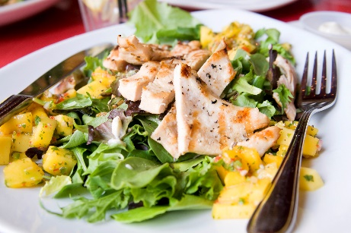  NUTRITIONAL  INFORMATION  160 Calories  15 g Protein  4.4 g Fat  0.6 g Saturated fat  15 g Carbohydrate  3.5 g Fiber  382 mg Sodium
DIRECTIONS
- In a small bowl, mix garlic, 1 tablespoon vinegar, 1 teaspoon oil, cumin, 1/4 teaspoon salt and cayenne. Spread evenly over both sides of meat. Cover and refrigerate at least 30 minutes or up to 3 hours.
- Peel and cut half the mango into chunks; cut the other half into slices and set aside. Place mango chunks, honey mustard, pineapple orange juice, remaining 2 tablespoons vinegar, 1/4 teaspoon salt and 1 teaspoon oil in a blender. Blend until smooth. Store in the refrigerator.
- Grill chicken or turkey over medium-high heat 3 to 4 minutes per side or until firm and opaque. Transfer to a cutting board and let stand 5 minutes. Cut crosswise into 1/2-inch-thick slices.
- In a large bowl, toss half of mango dressing with lettuces and bell pepper. Mound the salad on 4 dinner plates. Arrange chicken or turkey and mango slices on atop salads and spoon remaining dressing evenly over each.
 | This newsletter contains general health information and is not a substitute for your doctor’s care. You should consult an appropriate health care professional for your specific needs. Some treatments mentioned in this newsletter may not be covered by your health plan. Please refer to your benefit plan documents for information about coverage.

