UBA | WellnessWorksS | Your Logo Here
June 2019
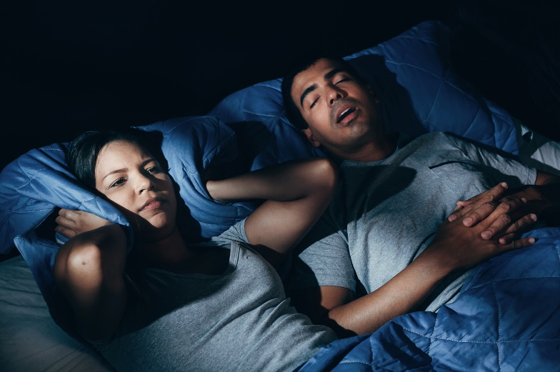  Snoring: The long and snort of it  Snoring has long been part of comedy skits (think The Three Stooges) and cartoon-character gags (remember Fred Flintstone?). Sure, there’s something funny about snoring — it can sound like anything from the braying of a sick donkey to the snorting of an angry bull to the cooing of a dove. And we love to tease people about their snoring. But actually, there’s nothing funny about it: Snoring can affect both the quality and the quantity of a person’s sleep, and this can lead to health problems. Snoring could also be a sign of a serious condition called obstructive sleep apnea.  So why do people snore, anyway? There are quite a few reasons. For instance, a narrowing of the throat, swollen adenoids, a cleft palate, congestion, being overweight, sleep position, and relaxed throat muscles caused by medications, drinking alcohol, or smoking are some common ones. And as most of us know, back sleepers tend to snore more than side or stomach sleepers.  Most of us snore from time to time — in fact, it’s thought that close to 50% of all American adults snore. Snoring doesn’t always indicate a serious problem, but it does mean that your airflow as you sleep isn’t moving as well as it should be. Plus, you can wake yourself up as well as anyone else who can hear you.  If you do snore, how do you know if it’s obstructive sleep apnea (OSA) that’s causing it? Typically, the snoring that comes with sleep apnea is very loud with ragged breathing and some choking sounds. But then come quiet periods that indicate breathing has almost stopped or stopped altogether. This can happen five times or more per hour. Soon the pause in breathing jolts the sleeper awake while they make gasping or snorting sounds. People with sleep apnea are usually very tired during the |  |  | Quick Takes  QuickTakes  Real-world time management  The smartphone era hasn't made time move any faster. But it can sure feel that way sometimes. Technology can make things easier but it can also suck up our time and increase stress. Set some ground rules for yourself.  - Log the number of minutes you spend on social media.  - Put away your phone while driving, at meals, and when trying to sleep.  - Set aside time to get active. You'll be paid back with more energy!  This month's newsletter takes a look at strategies to help you make the most of your time.  QuickTakes  Real-world time management  The smartphone era hasn't made time move any faster. But it can sure feel that way sometimes. Technology can make things easier but it can also suck up our time and increase stress. Set some ground rules for yourself.  - Log the number of minutes you spend on social media.  - Put away your phone while driving, at meals, and when trying to sleep.  - Set aside time to get active. You'll be paid back with more energy!  This month's newsletter takes a look at strategies to help you make the most of your time.  QuickTakes  Real-world time management  The smartphone era hasn't made time move any faster. But it can sure feel that way sometimes. Technology can make things easier but it can also suck up our time and increase stress. Set some ground rules for yourself.  - Log the number of minutes you spend on social media.  - Put away your phone while driving, at meals, and when trying to sleep.  - Set aside time to get active. You'll be paid back with more energy!  This month's newsletter takes a look at strategies to help you make the most of your time.  QuickTakes
All about sleep, A to Zzzzzz
There’s nothing like a good night’s sleep. Unfortunately, many Americans don’t get enough of it. And that’s a real problem, because lack of sleep can cause some serious issues. And we’re not talking about under-eye shadows or nonstop yawns — not getting enough sleep can cause issues well beyond what you might think.
Just about every living creature sleeps. For humans, it’s a natural, physiological process controlled by hormones. There are two sleep cycles. REM sleep (this is when we dream) and non-REM sleep (“quiet sleep”). REM is thought to help keep our minds sharp, while non-REM supports physical functioning.
Are you getting enough sleep? Most adults should get between seven and nine hours. But the quality of your sleep is just as important as the quantity. And what happens if you don’t get enough? It could lead to diabetes, heart disease, and other serious physical conditions. Lack of sleep can also affect you mentally and emotionally and can even lead to depression, and affect your productivity at work or your concentration while driving or using dangerous tools.
You can take charge, however, by practicing good sleep habits. Make sleep a priority. You’ll rest easier knowing it’s helping you stay healthy.
And speaking of rest: do you snore? If you rattle the roof every night, it could be the sign of a serious health problem. (Not to mention driving your bedmate crazy.) You can learn more about the snore in this month’s newsletter.
United Benefit Advisors | 20 N. Wacker Drive, Suite 500 Chicago, IL 60606 | www.ubabenefits.com

WellnessWorksS

UBA
day or may tend to fall asleep during normal waking times. OSA often gets worse over time. That’s why it’s important you talk to a health care provider if you suspect you might have it. Along with fatigue, slow reflexes, crankiness and even depression, OSA can lead to heart disease, liver problems, diabetes, or obesity.
There are treatments for OSA. Your health care provider may recommend using a special breathing device. The Continuous Positive Airflow Pressure (CPAP) machine is one of these. A mouth guard that adjusts your lower jaw to keep your airway open is another common treatment. Some cases may best be treated surgically.
Self-help tips for snoring include sleeping on your side, raising the head of your bed, using nasal strips, and doing jaw-muscle tightening exercises. If all else fails, you could take up the didgeridoo. This Australian wind instrument can help strengthen the throat and soft palate. That might bother the people you live with even more than your snoring, however.
Nobody snores on purpose. And nobody likes to be teased about it. If you’re the household snore-er, look into solutions and treatments. If you’re the snore-ee, keep in mind that no amount of elbow jabbing will help. Try to be patient — and invest in a good pair of earplugs.
Remember, snoring isn’t necessarily pretty, but we all do it. Keep this information in mind next time the bedroom window rattles, and do what it takes to get it under control. Sleep well and snore no more!
Sources:
Helpguide.org. Sleep apnea. https://www.helpguide.org/articles/sleep/sleep-apnea.htm (Accessed 4/29/19)
Helpguide.org. Tips to help you and your partner sleep better.
https://www.helpguide.org/articles/sleep/snoring-tips-to-help-you-and-your-partner-sleep-better.htm (Accessed 4/29/19)
The National Sleep Foundation. Snoring and sleep apnea. https://www.sleep.org/articles/snoring-and-sleep-apnea/ (Accessed 4/29/19)
The National Sleep Foundation. When is your snoring OK? https://www.sleep.org/articles;/when-is-your-snoring-ok/ (Accessed 4/29/19)
Mayo Clinic. Snoring. https://www.mayoclinic.org/diseases-conditions/snoring/symptoms-causes/syc=20377694 (Accessed 4/29/19)

 |  | Grilled Blackberry Chicken Salad Makes 4 servings
 | Sweet, sour and pungent all at once — you’ll be delighted at how well this unusual flavor combination works.  Takes 30-60 minutes.  INGREDIENTS  1/2 cup raspberry or balsamic vinegar  1/4 cup sieved blackberry or raspberry jam  2 tablespoons Dijon mustard  1 teaspoon sugar  4 4-oz. boneless, skinless chicken breasts  4 handfuls mixed baby greens  1 pint blackberries or raspberries  1 1/2 oz. crumbled mild boat cheese, such as goat’s milk feta  1/2 cup snipped fresh chives  Salt and freshly ground pepper  DIRECTIONS  - Combine vinegar, jam, mustard and sugar and blend vigorously until smooth. Pour half of the dressing over chicken in a shallow dish. Coat evenly and reserve the remaining dressing to coat the greens.  - Refrigerate for at least 10 minutes, or for up to one hour.  - Coat grill rack with cooking spray. Grill the chicken for six minutes on each side or until the flesh is opaque. Let stand for five minutes before cutting crosswise into thin slices.  - Mix greens with reserved dressing and divide among four plates. Sprinkle evenly with berries. Top with chicken slices. Garnish with goat cheese and chives, dividing evenly. Sprinkle with salt and pepper |  | NUTRITIONAL  INFORMATION  307 Calories  30 g Protein  7.1 g Fat  3.1 g Saturated fat  31 g Carbohydrate  4.8 g Fiber  627 mg Sodium
 | This newsletter contains general health information and is not a substitute for your doctor’s care. You should consult an appropriate health care professional for your specific needs. Some treatments mentioned in this newsletter may not be covered by your health plan. Please refer to your benefit plan documents for information about coverage.

