UBA | WellnessWorksS | Your Logo Here
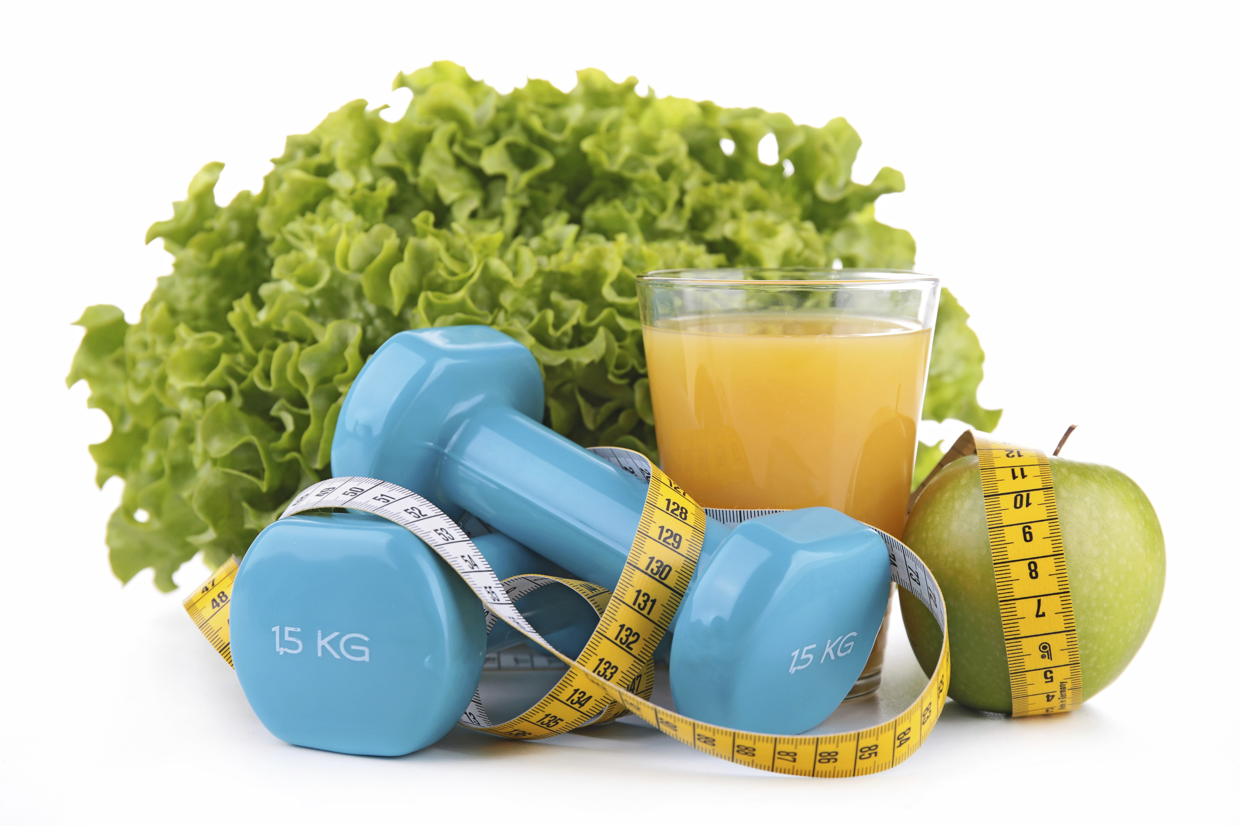
April 2019
Exercise and Health:  The Mind-Body Connection  Ever notice how you can get an overall feeling of well-being after taking a long walk, shoveling snow, dancing, or playing Frisbee with the kids? It’s not just because you can check “get some physical activity” off your to-do list. Turns out, there are physiological reasons why you get that feeling. And for people who suffer from a mental health condition like depression, anxiety or ADHD, exercise can relieve symptoms almost as well as medications, and can sometimes help certain symptoms from coming back.  How does it work? Researchers aren’t completely sure. But we do know that physical activity causes certain substances that affect brain function to kick in. These include:  - Endorphins – brain chemicals that reduce stress or pain and increase feelings of well-being  - Serotonin – a brain chemical that affects mood  - Glutamate and GABA – chemicals that influence parts of the brain that affect emotions and mental clarity  - BDNF (brain-derived neurotropic factor) – a protein that protects nerve cells in the brain that help control depression-like symptoms  Many people have found that exercise helps keep anger, stress, and muscle tension at bay and can help you sleep, which helps lessen stress, boost concentration, and improve self-esteem. In addition, it can help you cope with challenges in a healthier way, instead of turning to behaviors like drinking alcohol, which can actually make symptoms worse.  Recommendations for physical activity are the same for mental health benefits as they are for physical benefits: try for at least 150 minutes per week. But even one hour a week has been |  |  | Quick Takes  QuickTakes  Real-world time management  The smartphone era hasn't made time move any faster. But it can sure feel that way sometimes. Technology can make things easier but it can also suck up our time and increase stress. Set some ground rules for yourself.  - Log the number of minutes you spend on social media.  - Put away your phone while driving, at meals, and when trying to sleep.  - Set aside time to get active. You'll be paid back with more energy!  This month's newsletter takes a look at strategies to help you make the most of your time.  QuickTakes  Real-world time management  The smartphone era hasn't made time move any faster. But it can sure feel that way sometimes. Technology can make things easier but it can also suck up our time and increase stress. Set some ground rules for yourself.  - Log the number of minutes you spend on social media.  - Put away your phone while driving, at meals, and when trying to sleep.  - Set aside time to get active. You'll be paid back with more energy!  This month's newsletter takes a look at strategies to help you make the most of your time.  QuickTakes  Real-world time management  The smartphone era hasn't made time move any faster. But it can sure feel that way sometimes. Technology can make things easier but it can also suck up our time and increase stress. Set some ground rules for yourself.  - Log the number of minutes you spend on social media.  - Put away your phone while driving, at meals, and when trying to sleep.  - Set aside time to get active. You'll be paid back with more energy!  This month's newsletter takes a look at strategies to help you make the most of your time.  QuickTakes
Making time for exercise is easier than you think.
If you think getting physical activity means you have to join a gym, buy fancy workout wear, and spend hours of torturous sweating and straining, we’re happy to tell you that you’re wrong. Instead of “exercise” – which might make you think of things like rowing machines, barbells and cardio classes – just change the wording to “physical activity.” Because now, according to new guidelines put out by the Department of Health and Human Services, every time you get up off the chair and move has some benefit to your health.
While every little bit counts and is surely better than nothing, it’s still recommended that, ideally, you should try to get at least 150 minutes per week of moderate-intensity physical activity – things like a brisk walk or leisurely swimming. This might sound like a lot until you stop to think about it: that’s only about 22 minutes a day over the course of a week! And breaking it out into shorter stints like that is definitely A-OK. Of course if you can do more than 150 minutes – or if you’re doing a vigorous activity like a singles tennis match – you’ll enjoy even more benefits to your health. And also try to get in some muscle-strengthening exercises at least twice a week.
The health benefits of getting more activity are many: your risk for heart disease, diabetes, and even some cancers goes down. And in this issue of Impact, you’ll learn how physical activity is equally good for your mental health.
United Benefit Advisors | 20 N. Wacker Drive, Suite 500 Chicago, IL 60606 | www.ubabenefits.com

WellnessWorksS

UBA
shown to help with mood disorders like depression and anxiety and even substance use disorder. But people suffering from mental health conditions may find it hard to do even that small amount. No matter how much you try to convince yourself to get up and move, you just can’t get motivated.
If this happens, remind yourself that just a walk around the block is a great start. Don’t set yourself up for failure by telling yourself you “should” be doing more. Just start somewhere, and hopefully the benefits you start to notice will keep you motivated to build up from there. Finding an activity you actually enjoy can really help you stay motivated.
There’s no doubt that physical activity is beneficial for mind and body. And even just short spurts are helpful. But if you are having symptoms of depression, anxiety or another mental health condition, physical activity may not be enough. Always talk to your doctor or a therapist if your symptoms are troublesome — you may benefit from medication and/or talk therapy.
Whatever you do to boost your activity level – even taking the smallest of steps – give yourself lots of props. Getting started isn’t easy and staying motivated can be challenging. But try. It just might leave you feeling great.
Sources:
Anxiety and Depression Association of America. Exercise for stress and anxiety. https://adaa.org/living-with-anxiety/managing-anxiety/exercisestress-and-anxiety (Accessed 3/1/19)
Helpguide.org. The mental health benefits of exercise. November 2018. https://www.helpguide.org/articles/healthy-living/the-mental-healthbenefits-of-exercise.htm (Accessed 3/1/19)
Mental Health America. Exercise. http://www.mentalhealthamerica.net/conditions/fitness-4mind4body-exercise (Accessed 3/1/19)
Mental Health America. Get physically active. http://www.mentalhealthamerica.net/get-physically-active (Accessed 3/1/19)
Mayo Clinic. Depression and anxiety: Exercise eases symptoms. September 27, 2017. https://www.mayoclinic.org/diseases-conditions/
depression/in-depth/depression-and-exercise/art-20046495 (Accessed 3/1/19)
 |  | Spicy Beef Lettuce Wraps Serves 4
 | This Asian inspired dish diches the high-calorie tortillas and uses lettuce leaves for the wraps  Cook up this beef mixture and freeze it for an easy meal at some point in the future. Want to get the most out of your time? Double the recipe and freeze the mixture in two bags. Now you have two meals ready to pull out, re-heat and eat!  INGREDIENTS SERVE WITH  1 pound 95% lean ground beef 3 green onions, chopped  ½ cup chopped onion ¼ cup unsalted, dry-roasted  2 teaspoons minced garlic peanuts, chopped  1 teaspoon fresh ginger, peeled ¼ cup fresh cilantro,  and minced chopped  1 Tablespoon sesame oil 8 large Romaine leaves  2 Tablespoons low-sodium soy  sauce  1 Tablespoon hot water  ½ teaspoon honey  1 Tablespoon low-sodium hot chili sauce  1½ Tablespoons fresh lime juice |  | NUTRITIONAL  INFORMATION  279 Calories  27 g Protein  14 g Fat  4 g Saturated fat  11 g Carbohydrate  2 g Fiber  70 mg Sodium  70 mg Cholesterol
DIRECTIONS
- In a large skillet, cook ground beef and onions over medium heat until meat is almost cooked through and onions are soft.
- Add garlic and ginger and cook until meat is no longer pink and garlic and ginger are fragrant.
- In a small bowl, mix together sesame oil, soy sauce, water, honey and hot chili sauce. Pour over beef and stir to coat. Cook until slightly thickened.
- Remove from heat and stir in lime juice. Cool slightly and spoon into freezer bag.
- Do not freeze green onion, peanuts, cilantro or lettuce.
 | This newsletter contains general health information and is not a substitute for your doctor’s care. You should consult an appropriate health care professional for your specific needs. Some treatments mentioned in this newsletter may not be covered by your health plan. Please refer to your benefit plan documents for information about coverage.

