UBA | WellnessWorksS | Your Logo Here
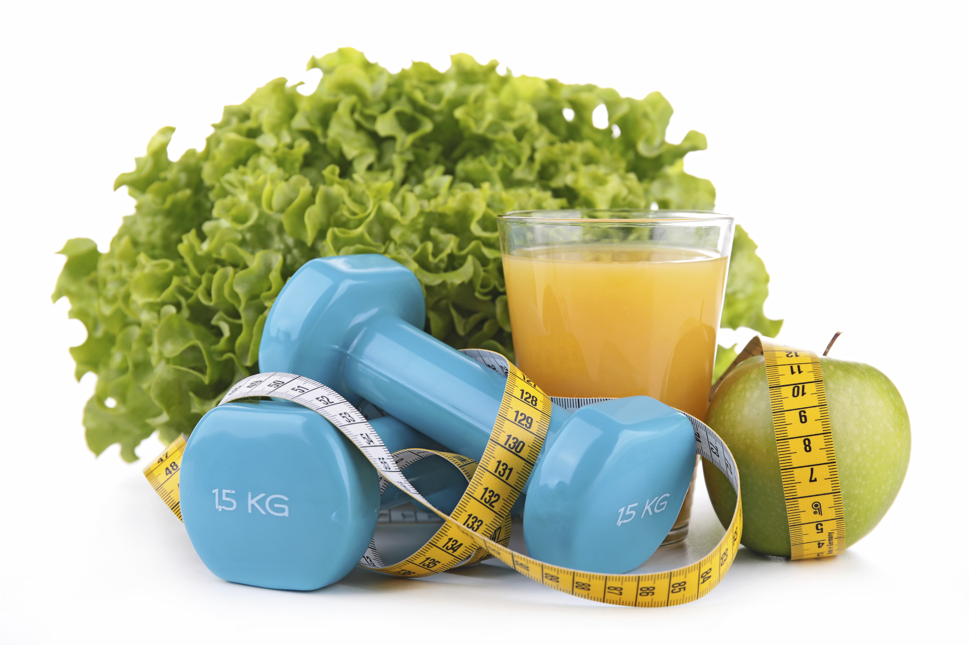
March 2019
Weight Loss: Myths vs. Facts  Eat this! Don’t eat that! Lose weight fast! Blast away calories with this best-ever workout routine!  Sound familiar? In your quest to lose weight by improving your diet and getting more exercise, you might be confused by all the information out there. Maybe you read something in a magazine. Maybe you saw an infomercial. How do you separate fact from fiction? Let’s look at some common misbeliefs—and get the lowdown on what’s actually legit.  No pizza. No ice cream. Ever.  This simply isn’t true. You can still enjoy your favorite fattening foods as long as the portions are small. Of course, the more you avoid these foods the better, because the are high in calories.  You have to exercise for hours at a time to make a difference.  Not so. It’s recommended that we get a minimum of 150 minutes a week of moderate-intensity activity. Spread that out over the week in any way you choose. Of course, if you go above the 150, that’s even better. And don’t forget to do strength training twice a week to build muscle.  Gluten-free is good for me.  Nope. Only If you have an issue with gluten or have celiac disease. And some gluten-free foods lack important nutrients. Gluten-free does not mean calorie-free. |  |  | Quick Takes  QuickTakes  Real-world time management  The smartphone era hasn't made time move any faster. But it can sure feel that way sometimes. Technology can make things easier but it can also suck up our time and increase stress. Set some ground rules for yourself.  - Log the number of minutes you spend on social media.  - Put away your phone while driving, at meals, and when trying to sleep.  - Set aside time to get active. You'll be paid back with more energy!  This month's newsletter takes a look at strategies to help you make the most of your time.  QuickTakes  Real-world time management  The smartphone era hasn't made time move any faster. But it can sure feel that way sometimes. Technology can make things easier but it can also suck up our time and increase stress. Set some ground rules for yourself.  - Log the number of minutes you spend on social media.  - Put away your phone while driving, at meals, and when trying to sleep.  - Set aside time to get active. You'll be paid back with more energy!  This month's newsletter takes a look at strategies to help you make the most of your time.  QuickTakes  Real-world time management  The smartphone era hasn't made time move any faster. But it can sure feel that way sometimes. Technology can make things easier but it can also suck up our time and increase stress. Set some ground rules for yourself.  - Log the number of minutes you spend on social media.  - Put away your phone while driving, at meals, and when trying to sleep.  - Set aside time to get active. You'll be paid back with more energy!  This month's newsletter takes a look at strategies to help you make the most of your time.  QuickTakes
Getting past a weight-loss stall-out.
Have you noticed that the diet and exercise routine you’ve been following isn’t giving you the results you’ve come to expect? Are you doing everything right, but your results seem all wrong? You’re certainly not alone. Most people reach a point in their weight-loss journey where everything seems to come to a halt. This is called a plateau.
Believe it or not, hitting a plateau isn’t all bad. It’s your body’s way of telling you that you’ve been doing a great job. But now your body has become accustomed to the diet and exercise routines you’ve been following. Your metabolism has slowed down, so your weight loss has, too.
Fear not. You aren’t stuck forever. If you want to keep losing, you are going to have to give your body a “jolt” by kicking things up a notch. Make sure you haven’t started taking in more calories. If so, cut down. And up your exercise game by getting more physical activity more often. You might also want to change up what you’re currently doing: Instead of the treadmill, try the elliptical, and go for 45 minutes instead of your usual 30. Increase the weight you’re lifting or the settings on weight machines. Your metabolism will fire up, and you should start seeing results again. And speaking of diet and exercise, read up on what’s true and what’s not in this month’s newsletter.
United Benefit Advisors | 20 N. Wacker Drive, Suite 500 Chicago, IL 60606 | www.ubabenefits.com

WellnessWorksS

UBA
Lifting weights just bulks you up
Highly unlikely, unless you’re training to be an NFL player. Doing strength training at least twice a week is super good for you. And it can help you lose weight because more muscle means you burn more calories.
Carbs are a big no-no.
No, no, not true. Sure, carbs in sugary foods like cookies and cake should be avoided, but whole grains, fruit, and other complex carbohydrates are an important part of a healthy diet.
The only way to lose weight is to do it slowly.
This can be true for some people but not for all. Check with your doctor on the best way for you to lose weight and keep it off long term.
No fats for you.
In fact, the body needs certain fats to function properly. But you should avoid saturated fats and, even more important, trans fats. “Good” fats like olive oil and avocados are higher in calories than foods like proteins and carbs, so keep portion size in mind.
The big takeaway.
The formula for losing weight through diet and exercise is really, really simple. Unless you burn more calories than you take in, you will gain weight. If you burn more than you eat, you’ll lose. And if you take in the same number of calories as those you burn, your weight will stay the same. No fad diet or exercise contraption will make a bit of difference unless you adhere to that basic fact.
Be sensible.
Eat healthy foods most of the time. If you have a treat, exercise more to make up the difference. Move your body—every little bit helps. And make sure the information you get about weight loss comes from sources you can trust.
Sources:
National Institute of Diabetes and Digestive and Kidney Diseases. Some myths about nutrition & physical activity. April 2017.
https://www.niddk.nih.gov/health-information/weight-management/myths-nutrition-physical-activity (Accessed 1/24/19)
MedlinePlus. Diet myths and facts. April 23, 2018. https://medlineiplus.gov/ency/patientinstructions/000895.htm (Accessed 1/24/19)
Helpguide.org. Choosing healthy fats. September 2018. https://www.helpguide.org/articles/healthy-eating/choosing-healthy-fats.htm (Accessed 1/24/19)

 |  | Asparagus Deluxe Serves 6
 | This roasted veggie combo is low-calorie as well as delicious! Asparagus, which is in season in the spring, is a good source of vitamins A and C. It’s also a good source of folate.  INGREDIENTS  Vegetable cooking spray  1 pound fresh asparagus, trimmed  ½ pound fresh mushrooms, quartered  ½ small onion, chopped  2 teaspoons olive oil  2 sprigs fresh rosemary, minced  Freshly ground black pepper to taste  DIRECTIONS  - Preheat oven to 450°F. Lightly spray a cookie sheet with cooking spray.  - Place asparagus, mushrooms and onions in a bowl. Drizzle with olive oil, then season with rosemary and pepper; toss well.  - Lay the asparagus mix out on the prepared pan in an even layer. Roast in the preheated oven until asparagus is tender, about 15 minutes. |  | 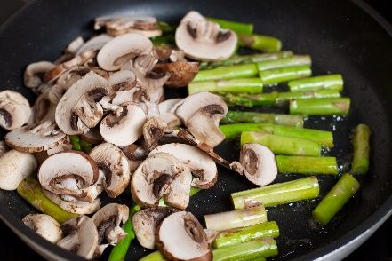  NUTRITIONAL  INFORMATION  39 Calories  3 g Protein  2 g Fat  0 g Saturated fat  4 g Carbohydrate  2 g Fiber  4 mg Sodium  0 mg Cholesterol

