UBA | WellnessWorksS | Your Logo Here
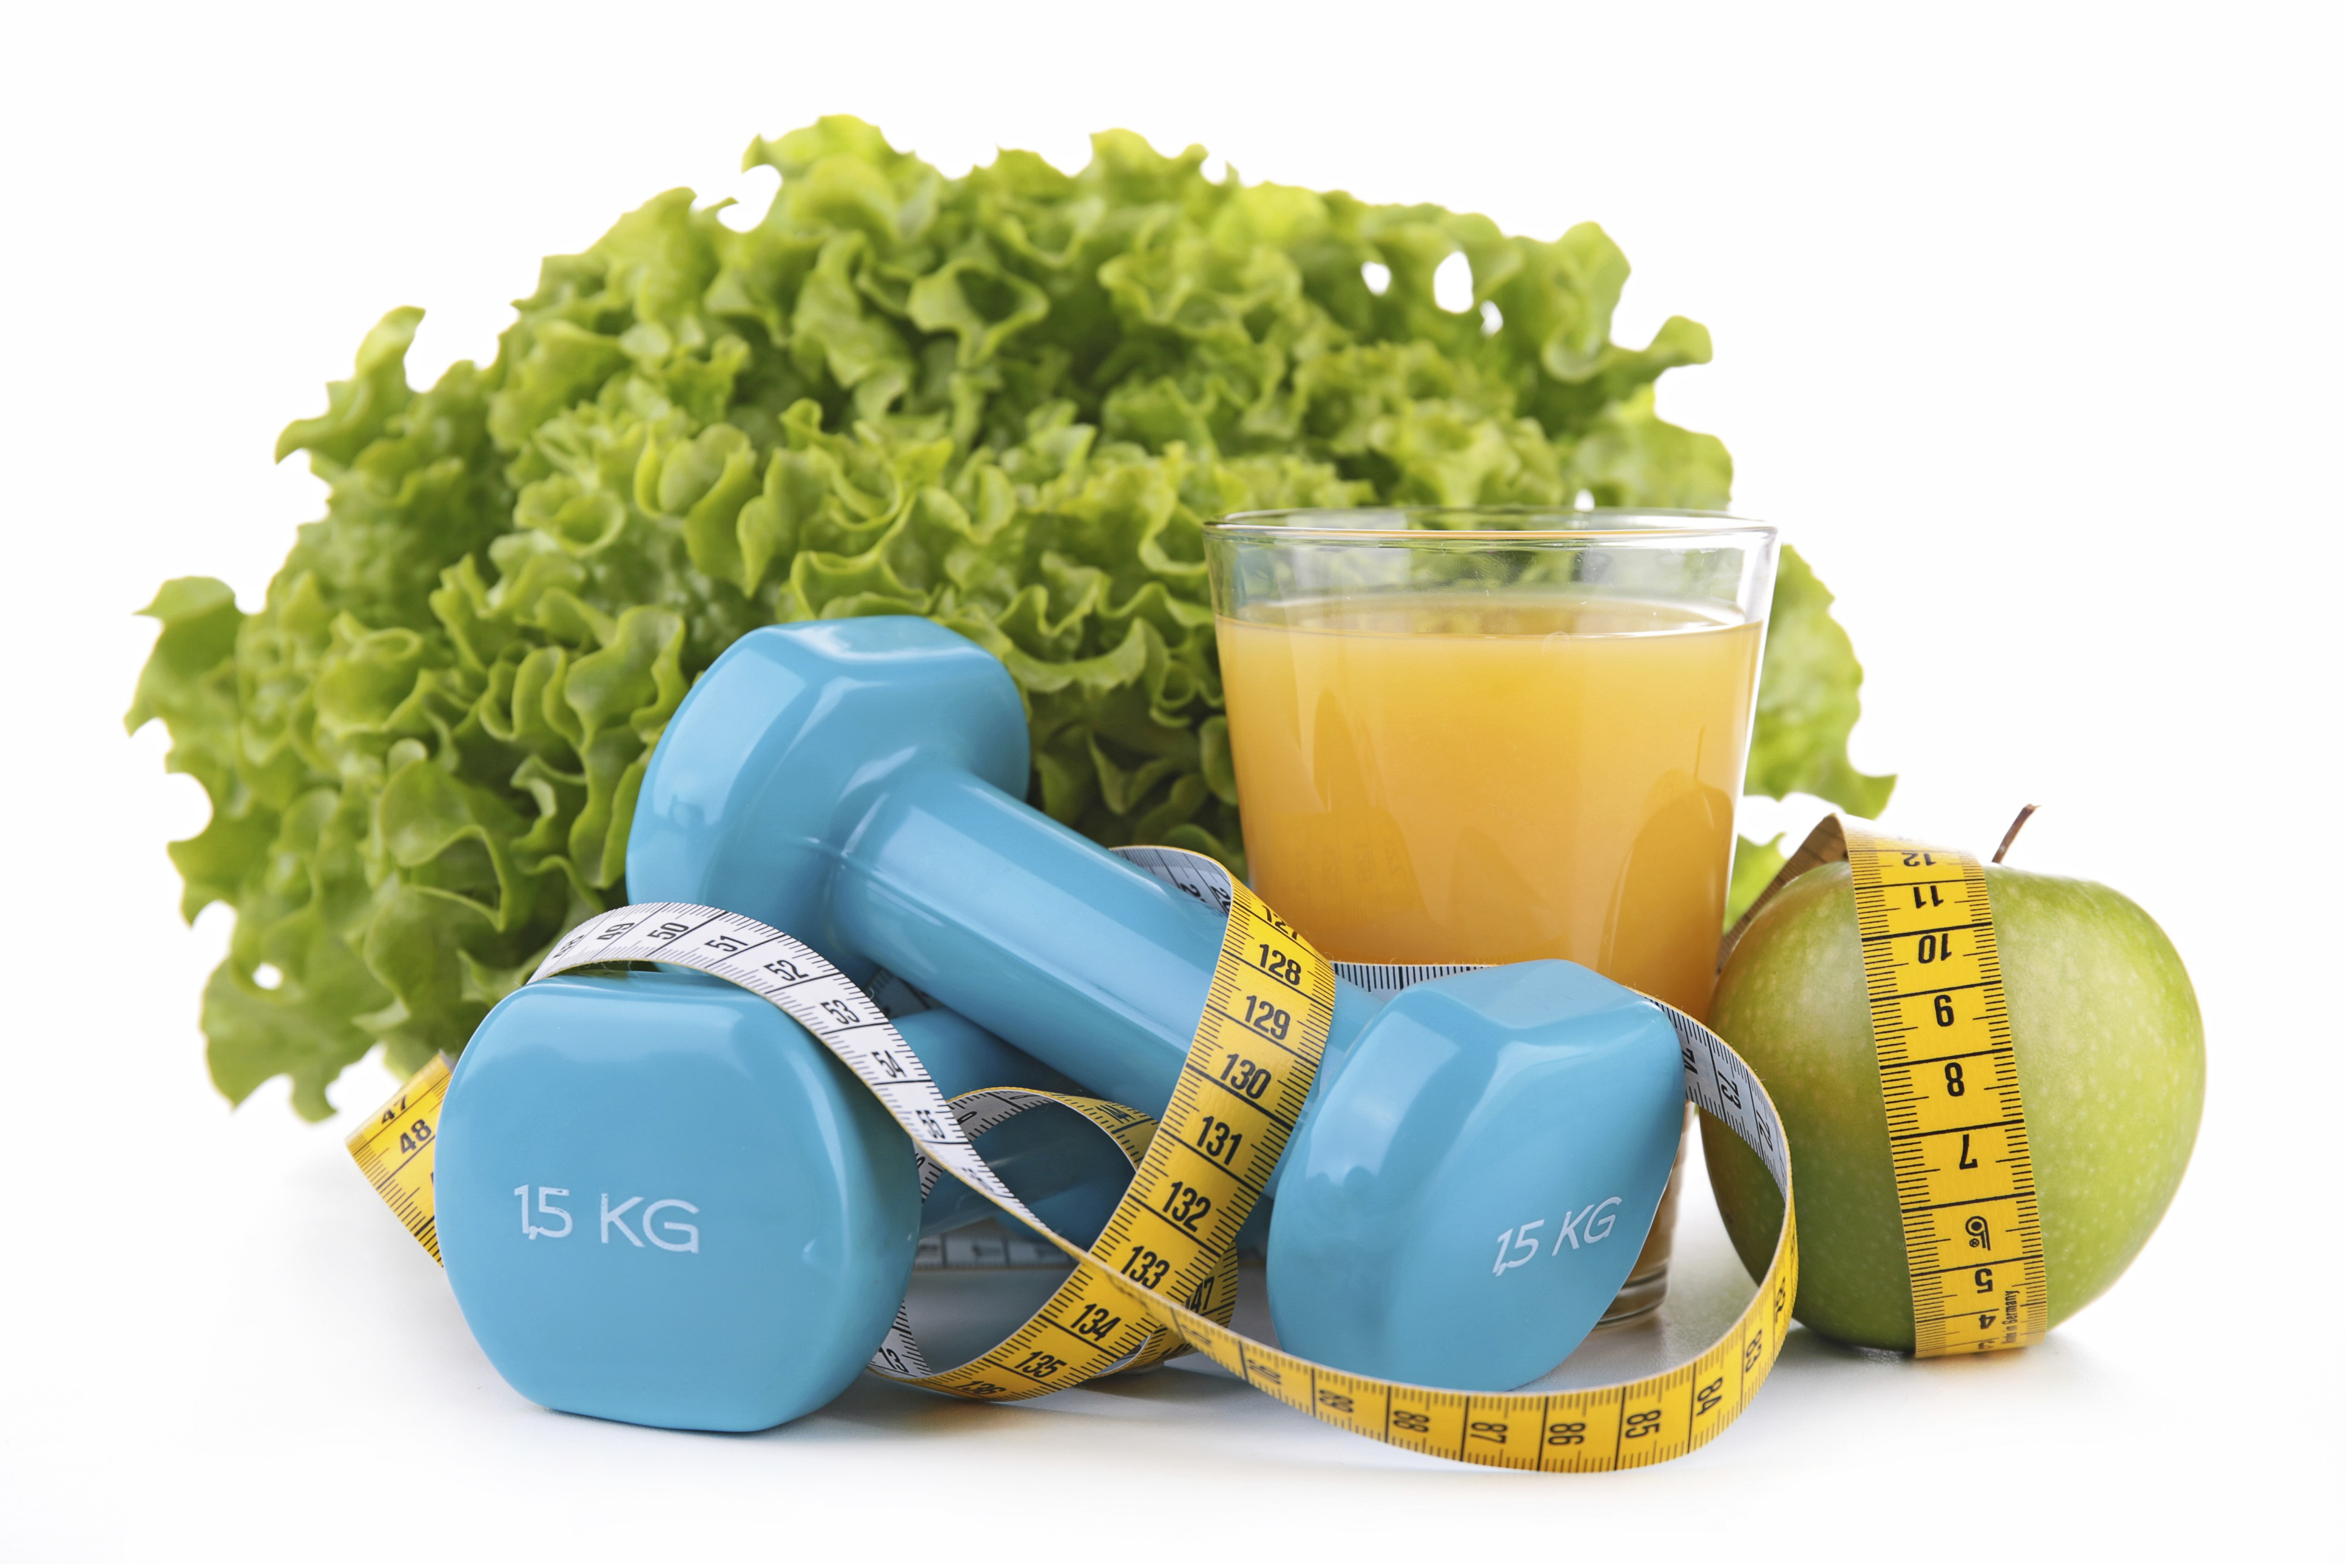
February 2019
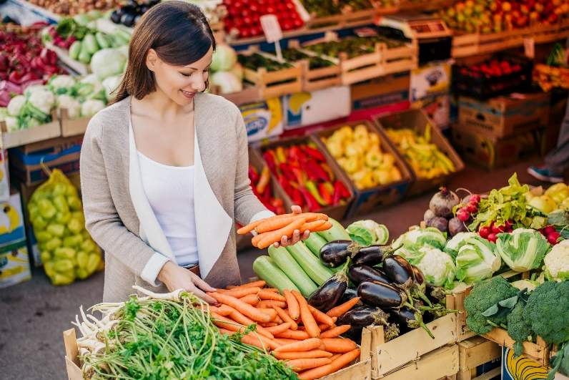  Seeds of Change  Why you should add more fruits and veggies to your diet  Has anyone ever said to you, “Eat your vegetables!”? Have you ever admonished your own kids to do the same? Are you guilty of throwing away the banana your mom packed in your lunch bag, or ignoring that apple you brought to the office — the one that’s now shriveled up and inedible?  Chances are you can answer “yes” to at least one of the above. While many people are trying to include more fruits and veggies in their diets, most of us could probably do better — in fact, most of us should probably eat twice what we’re currently eating. That’s because fruits and vegetables fill an incredible variety of essential nutritional needs and can help protect against certain diseases. These may include heart disease, type 2 diabetes, stroke, and even some cancers. They can also help reduce the risk of digestive and eye problems.  Veg out  Let’s hear it for vegetables. These colorful foods are cholesterol free and low in fat and calories. Depending on the variety, they offer vitamins A and C, folate, and potassium, along with fiber to aid digestion. The fiber also helps you feel fuller faster, which may help you stay away from less-nutritious, higher-calorie foods. They’re just as good for you whether cooked or raw, fresh, frozen, or canned, whole or chopped. Even 100% vegetable juice counts. Try to eat a wide variety, including red and orange (such as peppers and carrots), dark green leafy (such as spinach), peas and beans (such as lentils), and starchy (sweet potatoes). |  |  | Quick Takes  QuickTakes  Real-world time management  The smartphone era hasn't made time move any faster. But it can sure feel that way sometimes. Technology can make things easier but it can also suck up our time and increase stress. Set some ground rules for yourself.  - Log the number of minutes you spend on social media.  - Put away your phone while driving, at meals, and when trying to sleep.  - Set aside time to get active. You'll be paid back with more energy!  This month's newsletter takes a look at strategies to help you make the most of your time.  QuickTakes  Real-world time management  The smartphone era hasn't made time move any faster. But it can sure feel that way sometimes. Technology can make things easier but it can also suck up our time and increase stress. Set some ground rules for yourself.  - Log the number of minutes you spend on social media.  - Put away your phone while driving, at meals, and when trying to sleep.  - Set aside time to get active. You'll be paid back with more energy!  This month's newsletter takes a look at strategies to help you make the most of your time.  QuickTakes  Real-world time management  The smartphone era hasn't made time move any faster. But it can sure feel that way sometimes. Technology can make things easier but it can also suck up our time and increase stress. Set some ground rules for yourself.  - Log the number of minutes you spend on social media.  - Put away your phone while driving, at meals, and when trying to sleep.  - Set aside time to get active. You'll be paid back with more energy!  This month's newsletter takes a look at strategies to help you make the most of your time.  QuickTakes
Does a healthy diet really help your heart? The answer is a definitive “yes.” And here are two diets that make that easy.
For many of us, “diet” conjures visions of nonstop hunger, unsatisfying meals, and unrealistic expectations.
But “diet” can also refer to your overall eating patterns — the food choices you make and the portions you consume. Maybe your diet just needs to include more of the foods you know are good for you, and less of those that aren’t.
Eating right can lead to weight loss — but it can also do a lot of good for your heart health. Two eating patterns — the Mediterranean Diet and the Dietary Approaches to Stop Hypertension (DASH) Diet — are easy-to-follow, commonsense diets that emphasize foods that benefit not just our hearts, but our overall health.
To eat the Mediterranean way, you’ll cut way back on meat. Instead, you’ll focus on vegetables, healthy fats, nuts and legumes. Eating these foods has been shown to protect you from cardio-vascular diseases, high blood pressure, high cholesterol, cancer and Alzheimer’s and could help prolong your life. The DASH diet emphasizes a variety of health foods including lean meats and poultry, veggies, nuts and legumes and discourages unhealthy fats and sodium. While DASH was designed to help people lower their blood pressure, it’s a great diet for anyone interested in wholesome eating and its positive effects on overall health.
Based on these two diets, eating more fruits and veggies sounds like a good practice. In this issue of Impact, let’s learn more about exactly why these foods are good for us.
United Benefit Advisors | 20 N. Wacker Drive, Suite 500 Chicago, IL 60606 | www.ubabenefits.com

 |  |  |  | WellnessWorksS
More fruit? Sweet!

UBA
As with vegetables, fruits provide a host of nutrients. Potassium, vitamin C, folate, and fiber are just a few. In addition, fruits are low in sodium, calories and fat and have zero cholesterol. Some fruits contain plant chemicals (phytochemicals) that may play a part in keeping you healthy — but this is being looked into further by scientists. In general, though, a diet that includes plenty of fruit may help reduce the risk of stroke, type 2 diabetes, birth defects, and heart disease. The potassium in fruit may help with bone strength. And fruit may also protect against certain kinds of cancer. Like veggies, you can enjoy fruit fresh, frozen, whole, chopped or sliced, or as 100% juice.
How much?
So just how much do you need to consume to get “enough” fruits and veggies? It depends on your age, your activity level and whether you’re male or female. For adult women, 1½ to 2 cups of fruit and 2½ to 3 cups of vegetables per day is recommended. Men should strive for 2 to 2½ cups of fruit and 3 to 4½ cups of veggies. Try to eat a variety of each, as no one fruit or veggie will give you all the nutrients you need. If you try to make half the food on your plate fruit and vegetables, you’ll be well on your way to getting the earthborn nutrients they offer.
So think green. And red, yellow, orange, blue and purple. Experiment with different varieties and recipes. Sneak spinach into sauces and omelets. Make frozen treats from fresh fruit. There are so many ways to enjoy fruits and vegetables — and you’re sure to enjoy their health benefits, too.
Sources:
USDA. ChooseMyPlate.gov. Why is it important to eat vegetables? June 2015 https://www.choosemyplate.gov/vegetables-nutrients-health
(Accessed 1/3/2019)
USDA. ChooseMyPlate.gov. Why is it important to eat fruit? June 2015 https://www.choosemyplate.gov/fruits-nutrients-health
(Accessed 1/3/2019)
Healthyeating.org. Health benefits of vegetables. https://www.healthyeating.org/Healthy-Eating/All-Star-Foods/Vegetables
(Accessed 1/3/2019)
Healthyeating.org. Health benefits of fruits. https://www.healthyeating.org/Healthy-Eating/All-Star-Foods/Fruits (Accessed 1/3/2019)
Produce for the Better Health Foundation & the Centers for Disease Control. Fruits & Veggies – More Matters. Top 10 reasons to eat more fruits & vegetables. http://www.fruitsandveggiesmorematters.org (Accessed 1/3/2019)
Harvard School of Public Health. The nutrition source. Vegetables and fruits.
https://www.hsph.harvard.edu/nutritionsource/what-should-youeat/vegetables-and-fruits/ (Accessed 1/3/2019)
Helpguide.org. Healthy eating. https://www.helpguide.org/articles-healthy-eating/healthy-eating.htm (Accessed 1/3/2019)

 |  | Baked Salmon with lemon and onions Serves 4
 | “Fatty fish” is a misnomer — even the leanest beef has more saturated fat than this catch of the day. And salmon is loaded with heart-healthy omega-3s.  INGREDIENTS  1½ pounds (700 g) skinless Alaska king or sockeye salmon or Arctic char fillets (in 4 pieces)  2 large onions, very thinly sliced  1 teaspoon olive oil  ½ teaspoon fresh thyme leaves or 1 big pinch dried thyme  4 tablespoons white wine, dry vermouth or apple cider  2 lemons, scrubbed and very thinly sliced  DIRECTIONS  - Preheat oven to 450°F. Heat oil in an ovenproof skillet set over medium heat. Add onions and cook, stirring often, until soft and translucent, about 10 minutes. Stir in thyme and wine, vermouth or apple cider. Season with a little salt and pepper.  - Set fish fillets on top of onions. Lay lemon slices over all. Bake until the fish is cooked through, about 12 minutes depending on the thickness of the fillet.  - Discard lemon slices. Serve fish on the onions. Serve with brown basmati rice tossed with dried currants; steamed green beans. |  | 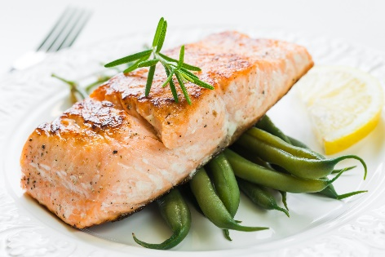  NUTRITIONAL  INFORMATION  214 Calories  32 g Protein  5 g Fat  1 g Saturated fat  8 g Carbohydrate  1 g Fiber  208 mg Sodium  33 mg Calcium

