UBA | WellnessWorksS | Your Logo Here
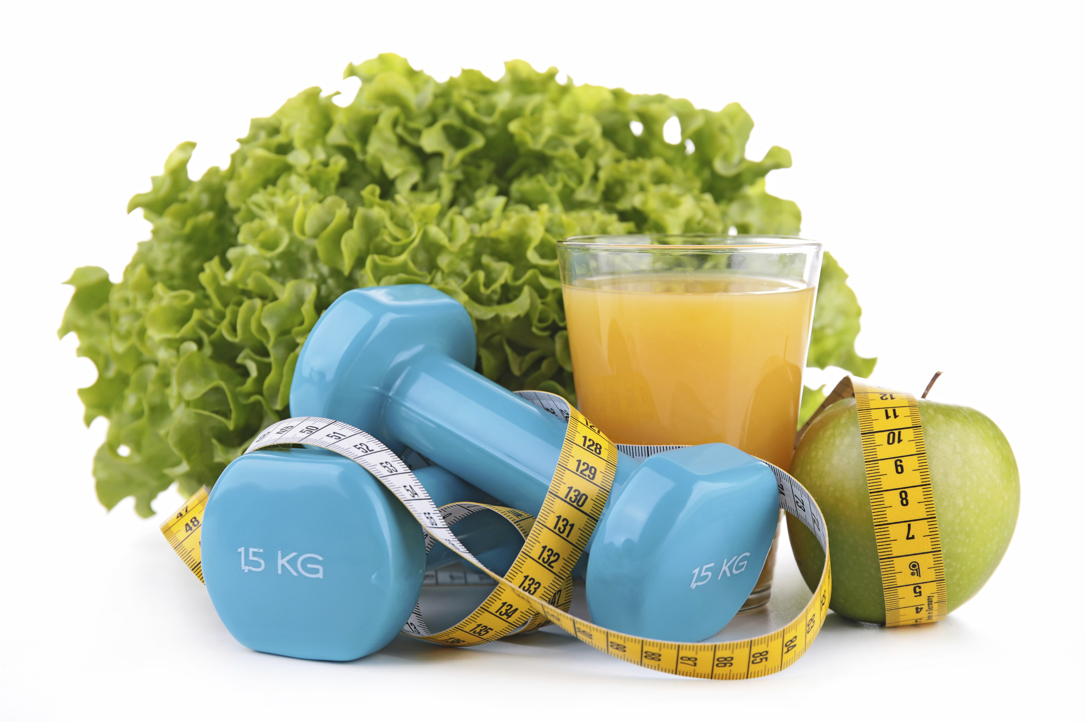
January 2019
The ins and outs of warming up and cooling down  OK, you’ve made it to the gym, you’ve donned your sneakers, and you’re ready to go! Or are you? If you’re headed for a workout, whether by yourself or in a group, it’s really important that you arm up before you get into it, and cool down when you’re done.  Feel the heat  Why warm up? It gets your body ready for activity by getting your blood flowing to your muscles. As your blood vessels dilate, your muscles get more oxygen to help them do the work you’re asking them to do. Warming up also raises your body temperature, increases respiration, and lets your heart rate rise gradually. This all helps your body get ready for the more vigorous activity you’re prepared to do. It’s kind of like pre-heating your oven before cooking.  In general, warm up with an easier, slower, less intense version of the exercise you’re planning to do. For instance, before going for a run, warm up by walking quickly for five or ten minutes. Your warm-up shouldn’t tire you out, but you might work up a mild sweat. Slightly longer warm-ups are best for people who are newer to exercise and for those who are getting ready for some extra-intense activity. |  |  | Quick Takes  QuickTakes  Real-world time management  The smartphone era hasn't made time move any faster. But it can sure feel that way sometimes. Technology can make things easier but it can also suck up our time and increase stress. Set some ground rules for yourself.  - Log the number of minutes you spend on social media.  - Put away your phone while driving, at meals, and when trying to sleep.  - Set aside time to get active. You'll be paid back with more energy!  This month's newsletter takes a look at strategies to help you make the most of your time.  QuickTakes  Real-world time management  The smartphone era hasn't made time move any faster. But it can sure feel that way sometimes. Technology can make things easier but it can also suck up our time and increase stress. Set some ground rules for yourself.  - Log the number of minutes you spend on social media.  - Put away your phone while driving, at meals, and when trying to sleep.  - Set aside time to get active. You'll be paid back with more energy!  This month's newsletter takes a look at strategies to help you make the most of your time.  QuickTakes  Real-world time management  The smartphone era hasn't made time move any faster. But it can sure feel that way sometimes. Technology can make things easier but it can also suck up our time and increase stress. Set some ground rules for yourself.  - Log the number of minutes you spend on social media.  - Put away your phone while driving, at meals, and when trying to sleep.  - Set aside time to get active. You'll be paid back with more energy!  This month's newsletter takes a look at strategies to help you make the most of your time.  QuickTakes
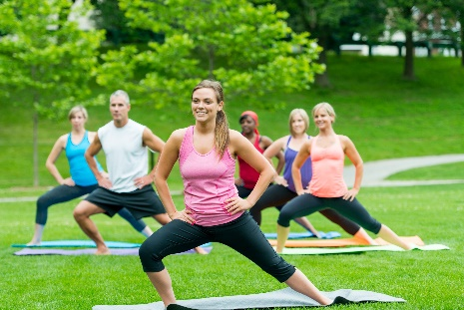
Get moving—and keep at it.
How to make exercise a regular part of your routine.
You know you should exercise. You totally get that. And you really, really, really mean it when you say you’re going to start doing it.
And maybe you do hit the gym for a few weeks, only to come up with some amazingly convincing excuses why you just can’t quite squeeze it in today. Or tomorrow. Or next week.
It’s hard to establish any new habit. But when approached the right way, getting into a groove with exercise – and sticking with it – is entirely doable. First, you have to switch up your thinking. For instance, if you think you’re too busy to exercise, take a careful look at your day and see where you might carve out some time. Chance are, you can finagle at least 20 or 30 minutes at least a few times each week. Or if you think exercise is boring, try out some different classes or routines until you find something that grabs you. Maybe it’s a Latin dance class. Or maybe it’s as simple as walking around your neighborhood. Whatever “moves” you!
Of course, you should check with your doctor before starting a new exercise program – he or she might have some suggestions or guidelines based on your health. Then, once you get the green light, make sure you start slowly and build up your endurance from there. Make your goals realistic, mix things up if you start getting bored with your activities, and give yourself credit for your progress.
And don’t forget to warm up and cool down before and after exercising. You’ll find the whys and hows in this month’s newsletter.
United Benefit Advisors | 20 N. Wacker Drive, Suite 500 Chicago, IL 60606 | www.ubabenefits.com

 |  |  |  | WellnessWorksS
Too cool to cool down?

UBA
Think cooling down is for wimps? Think again. When you stop exercising suddenly, the blood that’s been helping your muscles work can pool. And the heart and brain won’t get the oxygenated blood they need quite fast enough, which can cause you to feel dizzy or lightheaded, nauseous or even faint. You want your heart to get back to its resting rate gradually and allow your body the chance to recover.
As with warming up, cool down by doing the activity you’ve been doing, but at a slower, easier pace. Another part of cooling down that can be very beneficial is stretching once your heart rate slows down. Your muscles will still be warmed up, so they’ll be more flexible and primed for stretching. Just make sure your stretches are gentle, and that you don’t hold your breath, bounce, or stretch to soreness, cramping and stiffness.
Many people skip the warm-up and cool-down. After all, they make your workout last longer, and we’re always pressed for time these days. But to get the most out of your exercise routine — and to feel extra great afterwards —
a few added minutes on either end of your workout will be well worth it.
If you’re pregnant, have been physically inactive or have a health condition such as arthritis, diabetes or heart disease, check with your doctor before starting an exercise program or increasing your activity level. He or she can tell you what types and amounts of activities are safe for you.
Sources:
Centers for Disease Control and Prevention. Physical activity basics. November 2018. https://www.cdc.gov/physicalactivity/basics/index.htm (Accessed 11/30/18)
Health.gov. Physical activity guidelines for Americans. Second edition. 2018. https://health.gov/paguidelines/second-edition/pdf/Physical_Activity_Guidelines_2nd_edition.pdf#page=82 (Accessed 11/27/18)
American Council on Exercise. Three reasons to stay for the cool-down. February 2018. https://www.acefitness.org/education-and-resources/lifestyle/blog/6926/three-reasons-to-stay-for-the-cool-down (Accessed 11/27/18)
Helpguide.org. How to start exercising and stick to it. September 2018. https://www.helpguide.org/articles/healthy-living/how-to-startexercisingand-stick-to-it.htm (Accessed 11/27/18)
American Heart Association. Warm up, cool down. September 2014. https://www.heart.org/en/healthy-living/fitness/fitness-basics/warm-upcool-down
(Accessed 11/28/18)
Mayo Clinic. Aerobic exercise: How to warm up and cool down. August 2016. https://www.mayoclinic.org/healthy-lifestyle/fitness/in-depth/exercise/art-20045517
(Accessed 11/27/18)
American Academy of Orthopaedic Surgeons. Warm up, cool down and be flexible. https://orthoinfo.aaos.org/en/staying-healthy/warm-upcool-down-and-be-flexible/
(Accessed 11/30/18)
 |  | Twenty-Minute Chili Makes 4 servings
 | The hardest part of this recipe is opening the cans of beans, tomatoes and hominy. The chili’s flavor is deep and full, as if it simmered all day. Takes under 30 minutes.  INGREDIENTS  No-stick cooking spray 2 teaspoons ground cumin  1 onion, chopped 1 teaspoon dried oregano  2 cloves garlic, minced 1/8 teaspoon unsweetened  1 15-ounce (450g) can low-sodium cocoa  pinto beans, drained and rinsed 1 pinch cinnamon  1 14.5-ounce (435g) can Mexican- 1 16-ounce (440g) can yellow  Style stewed tomatoes, crushed hominy, rinsed  2 tablespoons chili powder Chopped cilantro or green  1 tablespoon chopped chipotle or onion  jalapeño peppers (from a can), Lime wedges  optional |  | NUTRITIONAL  INFORMATION  277 Calories  11 g Protein  2.4 g Fat  0.3 g Saturated fat  54 g Carbohydrate  13.1 g Fiber  288 mg Sodium
DIRECTIONS
- Spray a large, heavy saucepan with cooking spray and set over medium heat. Add onions and cook, stirring, until soft, about 5 minutes. Add garlic and cook 1 minute longer.
- Stir in beans, tomatoes, chili powder, chipotles (if using), cumin, oregano, cocoa and cinnamon. Bring to a boil and reduce the heat to low. Simmer for 10 minutes to blend the flavors. Add hominy and cook until heated through.
- Ladle into bowls and garnish with cilantro or green onions. Serve lime wedges alongside.

